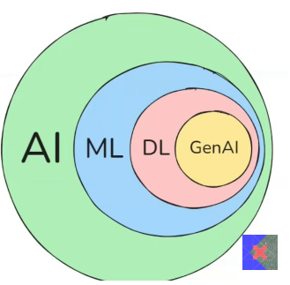**GenAI**

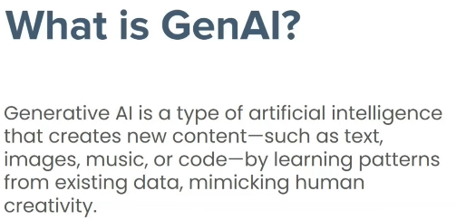

**GenAI Impact Areas**

1. Customer Support
2. Content Creation
3. Education
4. Software Development

**Mental Model**

**Builders Perspective**

**Users Perspective**

**Foundation Model**

**🧠 Foundation Model**

Large-scale AI models trained on massive datasets (often containing millions or billions of data points). These models require powerful computational resources and advanced hardware for training and can perform a wide range of tasks across domains (e.g., language, vision, code, etc.).

**👤 User's Perspective**

From the user’s side, Foundation Models are utilized to build applications. These users don't train the models from scratch but instead use APIs or tools built on top of foundation models (like ChatGPT, GitHub Copilot, DALL·E, etc.) to solve specific problems or integrate intelligent features into their products.

**🛠️ Builder's Perspective**

Builders are the researchers and engineers who work on creating, fine-tuning, or improving foundation models. This includes training models on large-scale data, optimizing performance, aligning them with ethical standards, and making them more efficient and generalizable for diverse tasks.

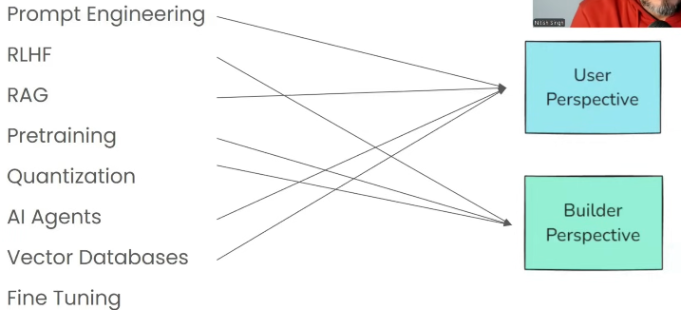

**The Builder’s Perspective**

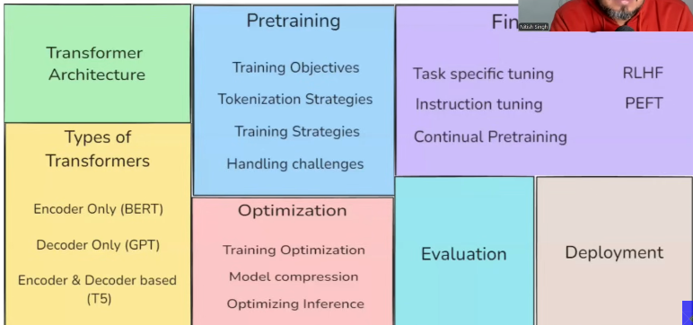

Fine Tuning

**The User’s Perspective**

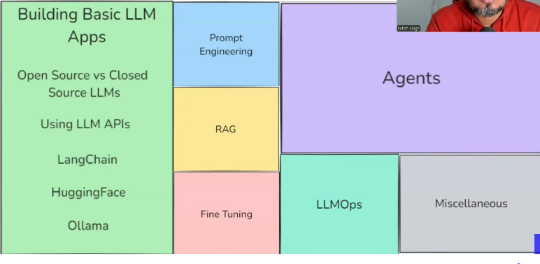

**Do we need to learn both?**

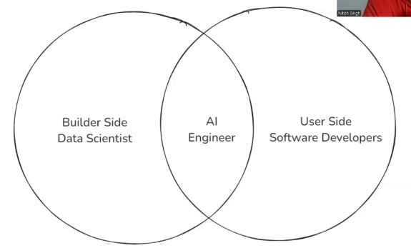

**If you want to become AI Engineer then yes.**

**LangChain**

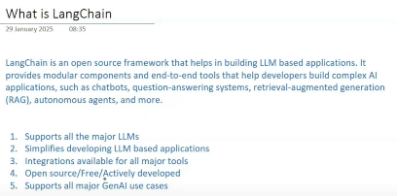

***LangChain Roadmap***

1. **Fundamentals** 
   1. **Introduction to LangChain**
   2. **LangChain Components**
   3. **Models**
   4. **Prompts**
   5. **Structured Outputs**
   6. **Output Parsers**
   7. **Chains**
   8. **Runnables & LCEL**
2. **RAG**
   1. **Document Loaders**
   2. **Text Splitters**
   3. **Vector Stores**
   4. **Retrievers**
   5. **RAG In Detail**
   6. **Building a Rag Application**
3. **Agents**
   1. **Tools & Toolkits**
   2. **Tool Integrations**
   3. **Building an AI Agent**

**Topic 1.1:** **Introduction to LangChain**

**Q.1. What is LangChain?**

**Ans.** LangChain is an open-source framework for developing applications powered by large-language-models (LLMs).

**Q.2. Why do we Need LangChain?**

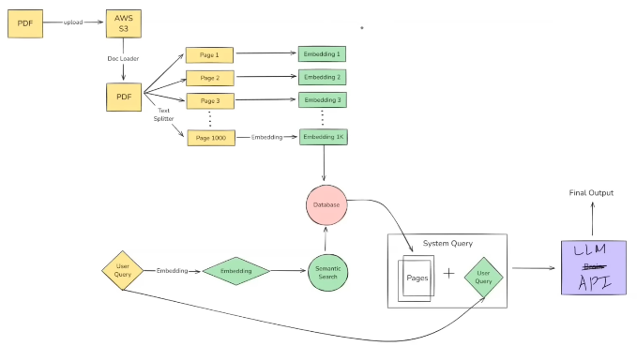

**Ans.** LangChain helps with the orchestration and management of all components and tasks in an LLM-based application. It provides built-in tools and abstractions that make it easier to develop, integrate, and manage various components such as prompts, memory, chains, agents, and tools.

**Q.3. What are the Benefits of LangChain?**

**1. Concept of Chains**Enables linking multiple LLM calls and logic steps together, creating complex workflows from simple components.

**2. Model-Agnostic Development**Supports integration with various LLMs (like OpenAI, HuggingFace, etc.), allowing flexibility in choosing or switching models.

**3. Complete Ecosystem**Offers built-in tools for prompts, agents, memory, and tools integration—reducing the need for external glue code.

**4. Memory and State Handling**Maintains conversational context and task state across interactions, making applications feel more intelligent and consistent.

**Q.4. What can you build through LangChain?**

1. Conversational Chatbots

2. AI Knowledge Assistants

3. Ai Agents

4. Workflow Automation

5. Summarization/Research Helpers

**Topic 1.2:** **LangChain Components**

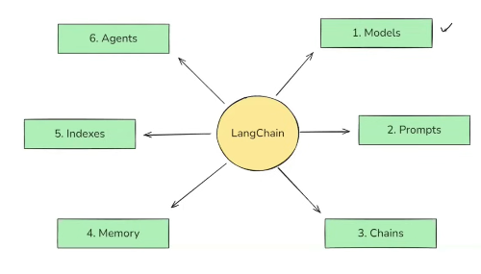

1. **Models**

In LangChain Models are the core interfaces through which you can interact with AI models.

* **Understanding Why Models are very Useful component of LangChain.**

In the history of NLP, one particular application that everyone wants to build is Chatbot, so for developing chatbot there are two major challenges, one is **NLU (Natural Language Understanding)** that machine have to properly understand the query given by user in natural language, and second is **Context Aware Text Generation** (to generate relevant response by the machine after understanding the natural language query), so when **LLMs** have introduced so they solves these 2 problems, but now **second problem arises** that as **LLMs** are train through whole internet data with billions of parameters so they are very huge in size like 100 GB, so normal users cannot process these huge models in normal PCs with normal hardware, and also normal small companies cannot be used through their cloud servers, because for that much large storage usage their cloud billing would be extremely high, so this problems solved by the big companies like **OpenAI, Google** in the way that they store and process **LLM** files in their servers and give us **APIs**  to communicate with **LLMs.** After that **3rd problem arises** of **Implementation**, as different companies write different methods, or different codes, different way to communicate with APIs

**For Example:**

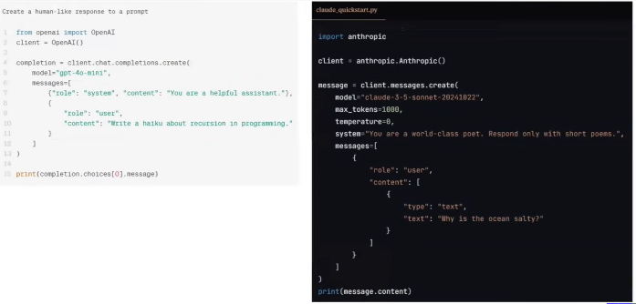

The Lighter one is for to communicate with OpenAI’s GPT model, and the darker one for communicate with Anthropic’s Claude-Sonnet Model.

So there is no standardization, because if you want to switch between these models in middle of development for some purposes, so you have to change a lot of things to adapt different model.

So LangChain provides a standard **Interface (Models)**  through which you can communicate with any company APIs with minimal changes of code.

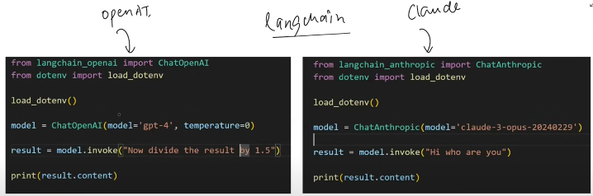

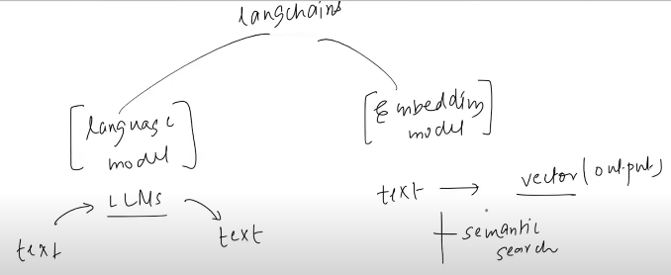

LangChain can communicate with two types of Models. Language Models and Embedding Models.

In Language Model, Text is provided as input and LLM’s output is as text.

In Embedding Model, Text is provided as input and LLM’s output is as vector.

1. **Prompts**

*Prompts are basically input provided to LLM.*

LLMs responses are greatly affected by prompts.

**For example:**1. Explain Linear Regression in Academic Tone

2. Explain Linear Regression in Fun Tone.

So LLMs are response is completely different for both prompts.

In LangChain you can create different kinds of dynamic and flexible prompts.

For example:

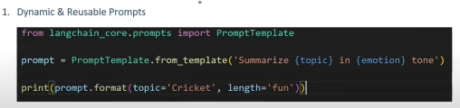

Dynamically different parameters, gives different responses.

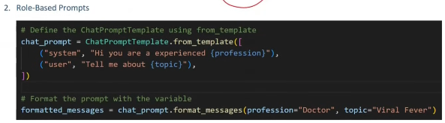

So here, you guide your LLMs through system level prompt that in what kind of profession you have to answer the user level prompt (topic).

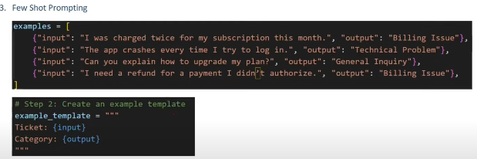 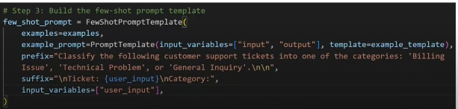

In this type, you have to define some few shots prompts like example prompt in a way that if this will be the input so what should be the output, and then you give example input to check whether it give correct output or not.

1. **Chains**

Chains help to create pipeline of application and input of one component will be the output of next component in the pipeline without manually doing this job.

**For example:**

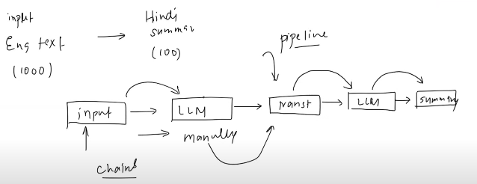

If you want to implement functionality in a way that you give input of 1000 English Letters and it Gives 100 words Summary in Hindi, so you have to design these pipeline manually and execute each task manually like taking input from user provided that input to 1st LLM that translates it in Hindi then provided that input to second LLM that summarize it 100 words so you have to manage all input outputs of pipeline implementation manually, whereas if you create this pipeline using **chains** so you have to only provides text as input and chains manage all further input outputs itself and give you summarized result.

Through LangChain we can create complex chains. Like **Parallel or Conditional chains.**

1. **Parallel Chains**

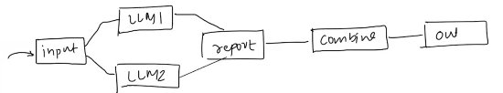

Like in this functionality you take input from user and pass it two different LLMs that generate reports and then these reports combine and gives output.

1. **Conditional Chain**

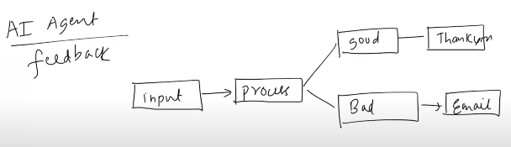

In this feature, you take feedback from user, if feedback is Good so it send thankyou message to user, if feedback is bad so it send email to customer support team.

**4. Indexes**

Indexes connect your application to external knowledge- such as PDFS, website or databases.

Indexes are comprises of four things.

1. Document Loader
2. Text Splitter
3. Vector Store
4. Retriever

For example:

If I ask ChatGPT about Leave Policy, or Notice Period about any random small company so it doesn’t answer it doesn’t know about that company’s data, because that is not in his training, so if you upload a pdf or give it some rule book about organization (external knowledge) so now it will be able to answer.



Retriever

Vector Database



Doc Loaders: Loads any kind of documents from storage.

Text Splitters: Helps in splitting od data like whole PDF into different Pages.

Vector Database: Stores Vector Embeddings.

Retrievers: Retrieve users’ query and convert into embedding for semantic search.

1. **Memory**

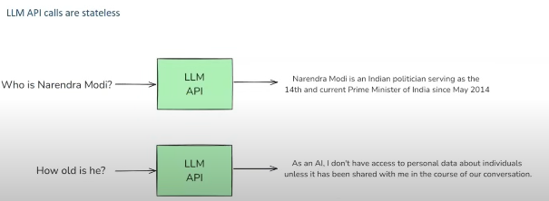

LLM API calls are **stateless**, meaning each request is treated independently, with no memory of previous interactions.

For example, if you ask:  
**“Who is Narendra Modi?”** — the model responds correctly.

But if you follow up with:  
**“How old is he?”**— the model may not understand who “he” refers to and could return an incorrect or incomplete response.

This happens because the model doesn't retain context between calls. The second request doesn’t know what was asked in the first, and the third won’t know about the second — **each request is completely independent** unless you manually provide the previous context.

**Here are some examples of memory:**

**1. Conversational Buffer Memory (CBM)**In CBM, the entire conversation history is stored and sent with every request to the API. This allows the model to understand the full context of the conversation when responding to the next prompt.

**2. Conversational Buffer Window Memory (CBWM)**In CBWM, only the most recent *N* number of interactions (e.g., the last 50, 100, or 200 messages) are stored and included with each request. This helps reduce overhead while still maintaining recent context.

**3. Summarizer-Based Memory (SBM)**SBM involves sending a summary of the previous interactions instead of the full conversation. This summary provides enough context for the model to continue the conversation effectively without the need to send the entire history.

**4. Custom Memory**For advanced use cases, you can implement custom memory to store specific information, such as user preferences, goals, or key facts about the user. This memory structure is tailored to your application’s unique requirements.

**6. Agents**

When we talk about Agents, it’s important to understand what makes them different from regular chatbots.

A typical chatbot mainly relies on two core components: **Natural Language Understanding (NLU)** and **Context-Aware Text Generation**. However, AI Agents not only include these features but also offer two additional powerful capabilities: **Reasoning** and **Access to External Tools**.

**For example:**  
Imagine I create an AI Agent and give it access to two tools: a **Calculator** and a **Weather API**.

Now, a user interacts with the agent and asks:  
**“Can you multiply today’s temperature in Karachi by 2?”**

Thanks to its reasoning ability, the agent starts analyzing the query. One common reasoning technique it may use is called **Chain-of-Thought Prompting**, which allows it to break down the query step by step.

1. First, the agent understands it needs to know the current temperature in Karachi.
2. It checks whether it has access to a tool that can fetch this information. Since it has the **Weather API**, it uses it to get the temperature — say, **35°C**.
3. Next, it realizes it needs to multiply this value by 2.
4. It then checks for a tool that can perform this operation. As it has a **Calculator**, it sends the input *(35, 2, ×)* to the calculator.
5. The calculator returns **70**, and the agent responds to the user with the result: **70°C**.

**Topic 1.3: Models**

**What are Models?**

The Model Component in LangChain is a crucial part of framework, designed to facilitate interactions with various **language models** and **embedding models.**

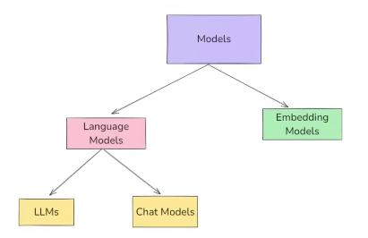

**Language Models:**  in which we provided text as input and received text as output.

**Embedding Models:**  in which we provided text as input and received vectors as output.

**1. Language Models**

Language Models are AI Systems designed to process, generate and understand natural language text.

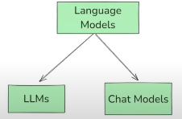

**LLMs** – General-purpose models that is used for raw text generation. They take a string(or plain text) as input and returns a string(plain text). These are traditionally older models and are not used much now.

**Chat Models** – Language models that are specialized for conversational tasks. They take a sequence of messages as inputs and return chat messages as outputs (as opposed to using plain text). These are traditionally newer models and used more in comparison to the LLMs.

| **Feature** | **LLMs (Base Models)** | **Chat Models (Instruction-Tuned)** |
| --- | --- | --- |
| **Purpose** | Free-form text generation | Optimized for multi-turn conversations |
| **Training Data** | General text (books, articles) | Fine-tuned on chat datasets (dialogues, user-assistant conversations) |
| **Memory & Context** | No built-in memory | Supports structured conversation history |
| **Role Awareness** | No understanding of "user" and "assistant" roles | Understands "system", "user", and "assistant" roles |
| **Example Models** | GPT-3, Llama-2-7B, Mistral-7B, OPT-1.3B | GPT-4, GPT-3.5-turbo, Llama-2-Chat, Mistral-Instruct, Claude |
| **Use Cases** | Text generation, summarization, translation, creative writing, code generation | Conversational AI, chatbots, virtual assistants, customer support, AI tutors |

**(Closed Source)**

**1. LLM**

**OpenAI (LLM)**

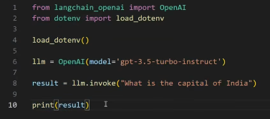

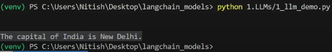

**2. Chat Modals**

**2.1. OpenAI**

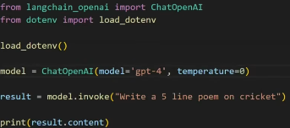

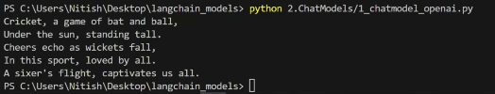

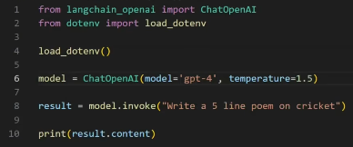

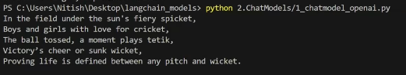

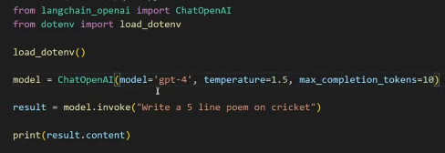



The **temperature** parameter controls the randomness or creativity of a language model's output—lower values (e.g., 0.2) make responses more focused and deterministic, while higher values (e.g., 0.8) produce more diverse and creative outputs. The **max_completion_tokens** parameter limits the number of tokens (roughly words or word parts) the model can generate in its response, helping control the length, cost, and processing time.

**2.2. Anthropic**

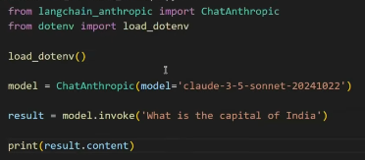 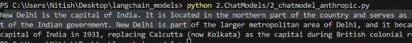

**2.3. Google**

from langchain_google_genai import ChatGoogleGenerativeAI

from dotenv import load_dotenv

load_dotenv()

model = ChatGoogleGenerativeAI(model="gemini-1.5-flash")

result = model.invoke('What is the capital of Pakistan?')

print(result.content)



**(Open Source Modals)**

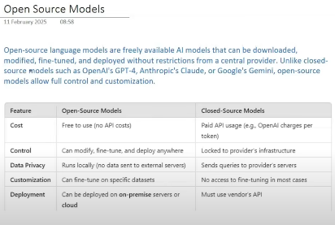

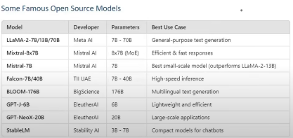

**Where to find them?**

**HuggingFace: The largest repository of open source LLMs**

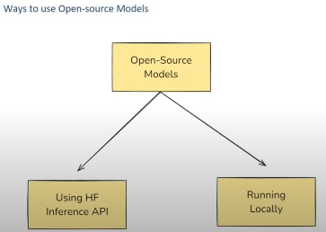

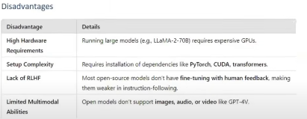

**Example 1 (Through Inference API) :**

**Model : TinyLlama/TinyLlama-1.1B-Chat-v1.0**

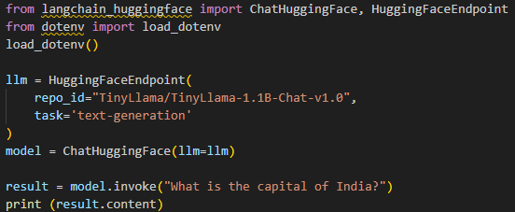

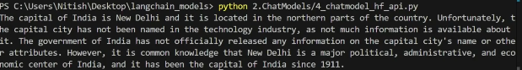

**Example 2 (Through Running Locally) :**

**Model : TinyLlama/TinyLlama-1.1B-Chat-v1.0**

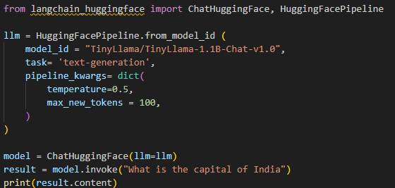

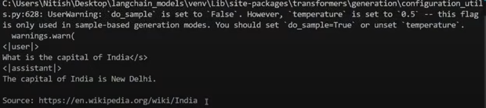

**2. Embedding Models**

**(Closed Source)**

**Example 1:**

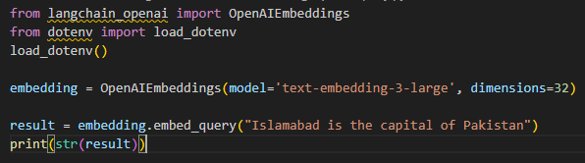

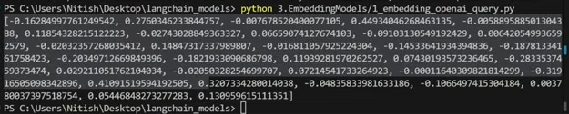

**(Open Source)**

**Example 2:**

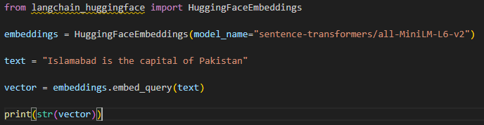

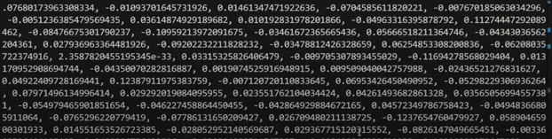

**Topic 1.4: Prompts**

**What are prompts?**

**Prompts** are the input instructions or queries given to a model to guide its output.

There are basically two kinds of prompts:

1. Text based

2. Multimodal (image + text, voice + text, videos, etc.)

* Text based prompts are used normally more than multimodal

**Static vs Dynamic Prompts**

**1. Static Prompts**

Static prompts are fixed input fields where users are allowed to write their entire queries freely, without constraints or predefined structures

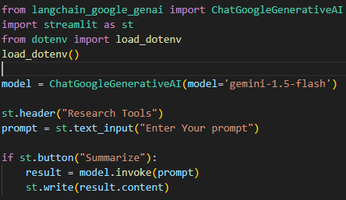

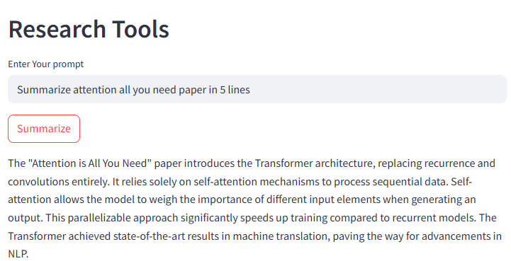

Static Prompt



The problem with static prompts is that the results are heavily influenced by the user's input. If the user doesn't understand the research paper or provides incorrect information, the model may hallucinate and produce inaccurate responses. For example, if the developer designed the model to summarize research papers using creative analogies, but the user wants a different type of summary, the output won't match the intended behavior. This leads to inconsistent results. To avoid this, you should use dynamic prompts and restrict users from writing unpredictable or unstructured queries. Ideally, when building an LLM-based application, you want to ensure a consistent environment and output behavior.

***To resolve these issues, you have to design a template and used dynamic prompt with it.***

**2. Dynamic Prompts**

Please summarize the research paper titled "{paper_input}" with the following specifications:

Explanation Style: {style_input}

Explanation Length: {length_input}

1. Mathematical Details:

   - Include relevant mathematical equations if present in the paper.

   - Explain the mathematical concepts using simple, intuitive code snippets where applicable.

2. Analogies:

   - Use relatable analogies to simplify complex ideas.

If certain information is not available in the paper, respond with: "Insufficient information available" instead of guessing.

Ensure the summary is clear, accurate, and aligned with the provided style and length.

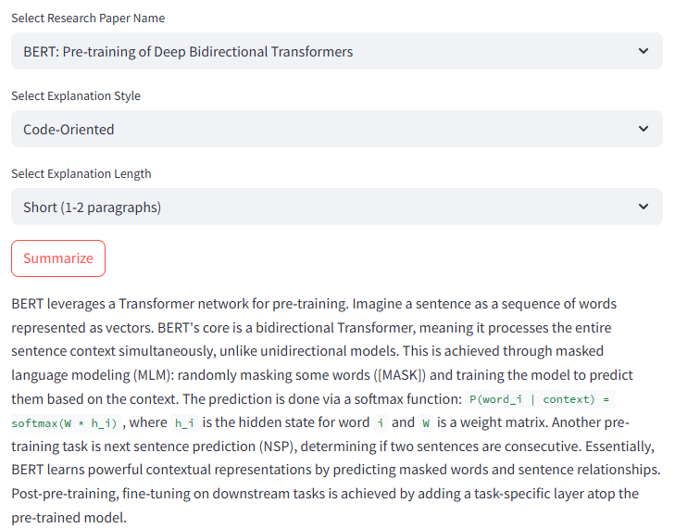

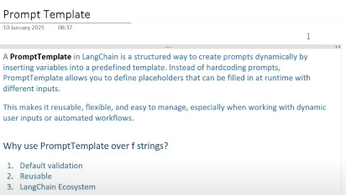

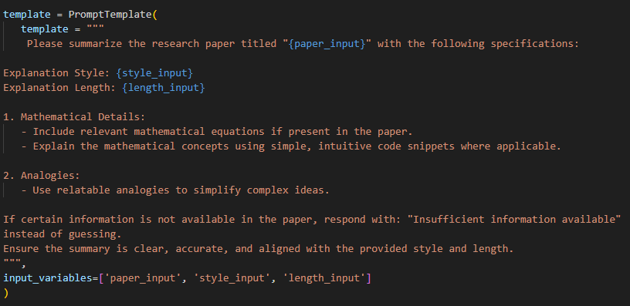

* **Messages**

For understanding messages, let’s create a simple chatbot.

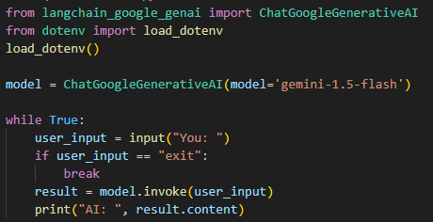

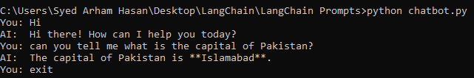

**By Seeing it looks like it is working normally, but there is problem with it. Now I explain it below:**

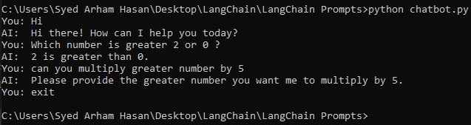

As you see, it does not maintain context of my interactions, means each calls acts independently, and when I said to multiply greater number by 2 so it was not able to understand the context of greater number, means each API call to LLM is stateless.

To solve this problem, we have to maintain some **chats history**, and send that history while interacting with model.

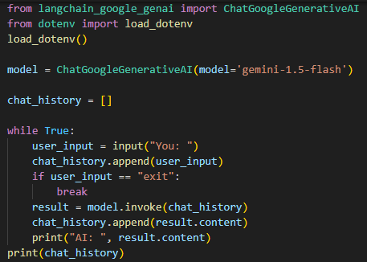

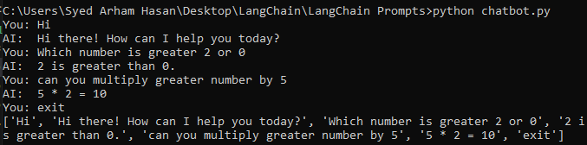

Now the context remembering problem resolved, but one more problem still have to resolve, as you see chat history there is no way to identify which interaction(chat) belongs to whom, means either the chat is belong to user or AI model, and as the chat history grows, it will become problem for Model to understand proper context and starting to produce wrong results.

**So LangChain understand this problem and provides concept of Messages.**

**There are 3 kinds of Messages in LangChain**

**1. System Message**

*“Sets the behavior, tone, or rules for the AI before the conversation starts.”*

SystemMessage(content="You are a polite assistant that explains scientific topics with analogies.")

**2. Human Message**

*“Represents the user’s input or query in the conversation.”*

HumanMessage(content="Explain linear regression in simple terms.")

**3. AI Message**

*“Represents the AI’s response generated during the conversation.”*

AIMessage(content=" Linear regression is like drawing the best straight line through a set of dots (data points) to predict something.")

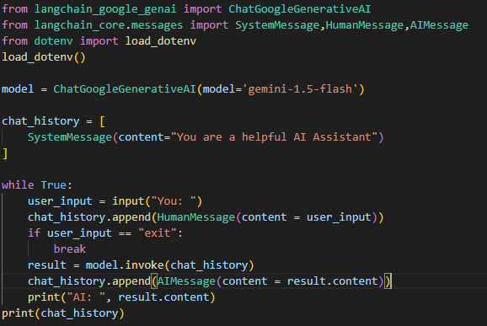

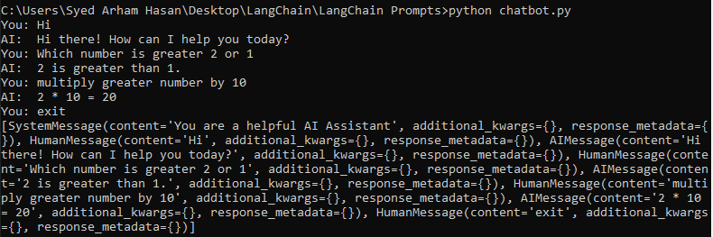

So now model will properly understand about which interactions (chats) provided by whom, it also gives some additional parameters, which can be utilize if needed.

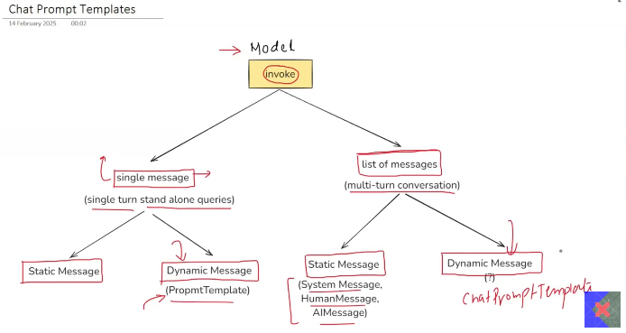

Till now we cover all of the things, for making list of message dynamic we can use **ChatPromptTemplate.**

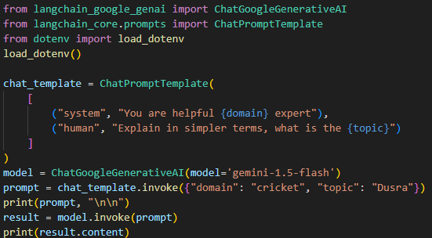



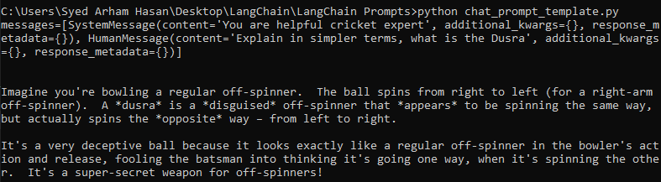



* **Message Placeholder**

A **Message Placeholder** in LangChain is special placeholder used inside **ChatPromptTemplate** to dynamically insert chat history or list of messages at runtime.

**For example:**

A customer chats with a customer care chatbot to request a refund for an order. The chatbot generates the refund request and informs the customer that the refund will be processed within 2–3 days. However, after 2–3 days, the customer returns to the chatbot to ask about the refund again. Since the chatbot doesn’t retain memory of past interactions by default, it cannot recall the previous conversation.

To solve this, we store the user's chat history in a database and reinsert it before the new user request, so the chatbot can understand the full context. This is where a **Message Placeholder** is used — to inject historical messages into the conversation, enabling continuity across sessions.

**Consider this user’s chat history stored in a file named chat_history.txt for now.**



**Code:**

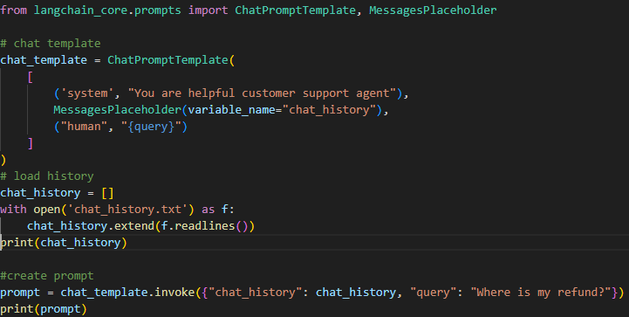

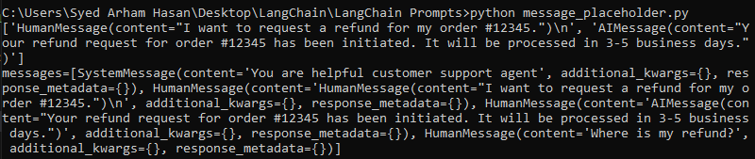

As show, first a System Message appears, then history of messages appears and then user’s new query.

**Topic 1.5: Structured Output**

**Structured Output:**

Structured output refers to the practice of having language models return responses in a well -defined data formats (for example JSON) rather than free-form text. This makes the model output easier to parse and work with programmatically.

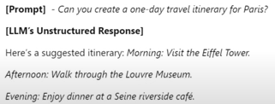

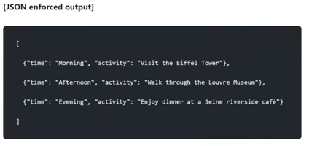

This above JSON enforced output is called structured output.

* **Why do we Need Structured Output**

**1. Data Extraction:** for example, a person uploads a resume, and model gives (Name, last education, contact, etc.) in JSON format, and so we can store in Database.

**2. API Building:** for example, you can write a code that take review of a certain product and talk about review’s (Topic, Pros, Cons, Sentiment) and then this API can be given to anyone.

**3. Agents:** for example, An Agent that has access about the tool (calculator), so if user writes a query **to calculate square root of 2**, so we cannot send this input directly to calculator because calculator will not be able to understand this **text format** so if model produce structured output in form of JSON in a way (operator = , number = 2) and then send this request to calculator, so now calculator will able to respond correctly.

So, in conclusion, unstructured output (text) can be useful for interacting with humans, but not with systems like Databases, APIs and tools, etc. for that purpose structured output is required in some proper formats like JSON, etc.

* **Ways to get Structured Output**

with_structured_output ()

Output Parsers

**Can**

**Can’t**

LLMs

Some of the LLMs have the ability to produce structured output, so it will be done through **with_structured_output** function. Some of the LLMs that do not have the ability to produce structured output, so it will be done through **Output Parsers**.

* **with_structured_output ()**

There can be three ways through you can specify data-formats for **with_structured_output ().**

**1. TypedDict**

**2. Pydantic**

**3. JSON Schema**

**1. TypeDict**

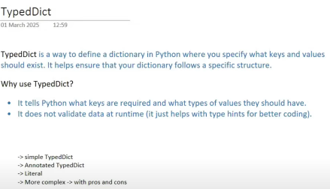

**1. Simple TypeDict**

For example: We define a class that is inherited from TypedDict in which we specify what are attribute that will return in result

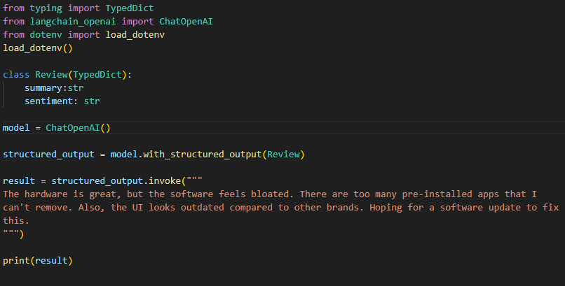



So, the model is intelligent enough to understand those attributes and respond accordingly based on the review, because a prompt is passed to the model for this request in below manner

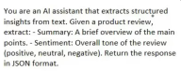

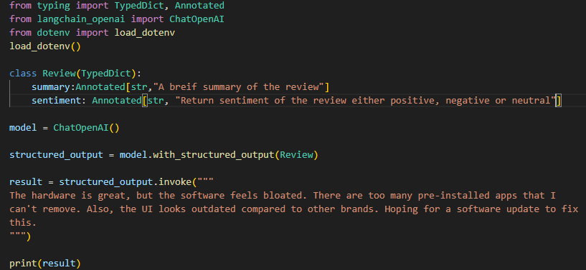**2. Annotated TypeDict**

**Annotated (Helps to define brief overview about the attribute so model do not make a mistake)**

**3. More Complex (TypeDict) with pros and cons**

from typing import TypedDict, Annotated, Optional, Literal

from langchain_openai import ChatOpenAI

from dotenv import load_dotenv

load_dotenv()

class Review(TypedDict):

    key_themes: Annotated[list[str], "Write down all the key themes discussed in review in a list"]

    summary:Annotated[str,"A breif summary of the review"]

    sentiment: Annotated [Literal ["pos", "neg"], "Return sentiment of the review either positive, negative or neutral"]

    pros: Annotated[Optional[list[str]], "Write down all the pros inside a list"]

    cons: Annotated[Optional[list[str]], "Write down all the cons inside a list"]

model = ChatOpenAI()

structured_output = model.with_structured_output(Review)

result = structured_output.invoke("""

I recently upgraded to the Samsung Galaxy S24 Ultra, and I must say, it's an absolute powerhouse! The Snapdragon 8 Gen 3 processor makes everything lightning fast—whether I’m gaming, multitasking, or editing photos. The 5000mAh battery easily lasts a full day even with heavy use, and the 45W fast charging is a lifesaver.

The S-Pen integration is a great touch for note-taking and quick sketches, though I don’t use it often. What really blew me away is the 200MP camera—the night mode is stunning, capturing crisp, vibrant images even in low light. Zooming up to 100x actually works well for distant objects, but anything beyond 30x loses quality.

However, the weight and size make it a bit uncomfortable for one-handed use. Also, Samsung’s One UI still comes with bloatware—why do I need five different Samsung apps for things Google already provides? The $1,300 price tag is also a hard pill to swallow.

Pros:

Insanely powerful processor (great for gaming and productivity)

Stunning 200MP camera with incredible zoom capabilities

Long battery life with fast charging

S-Pen support is unique and useful

Cons:

Bulky and heavy—not great for one-handed use

Bloatware still exists in One UI

Expensive compared to competitors

""")

print(result)

**Optional:** Represents that the attribute is optional means if this description is not available in this text like pros or cons so it will not show in output.

**Literal:** Through this you can specify options in which answer should be give like (pos, neg)

*But there is a problem with TypeDict that it only represents that that should be in particular format like (str, int, etc.) but it does not validate or thrown error if the data is not in specified format or not. for example, if we write that age should in* ***str*** *format and age is given in* ***int*** *format so it will not throw error.*

**2. Pydantic**

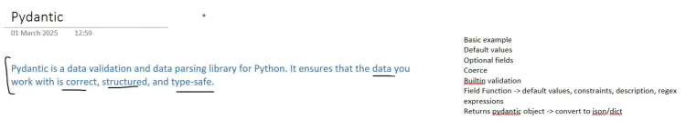

**Demo:**

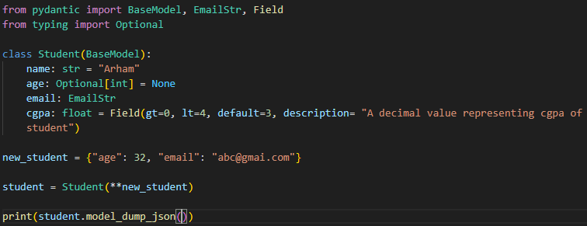



**Now example with above template of complex TypeDict:**

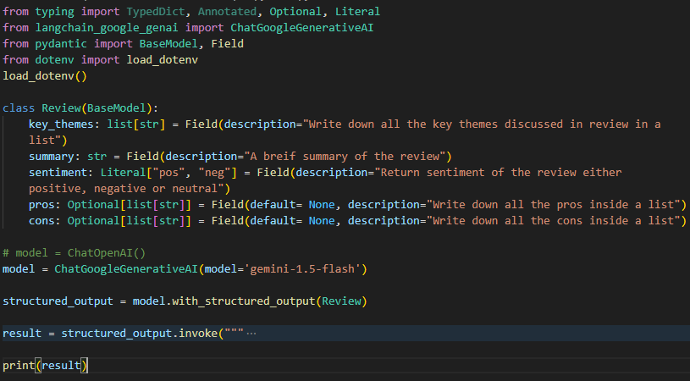

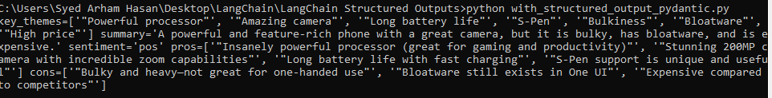

**3. JSON Schema**

Demo Schema:

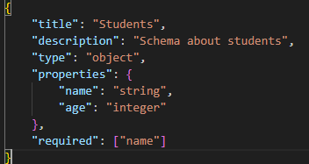

**Now JSON Schema Example with above complex review**

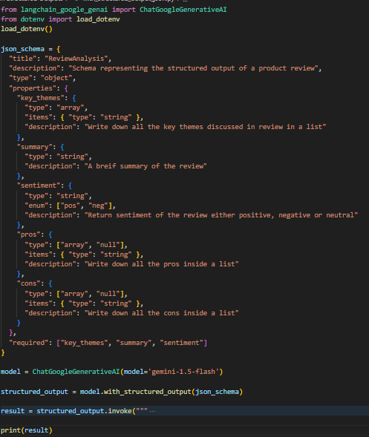

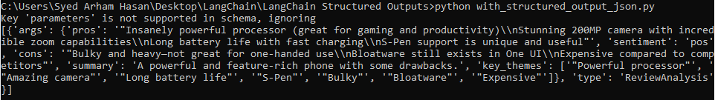

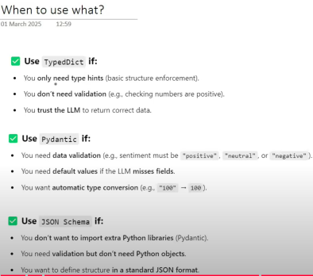

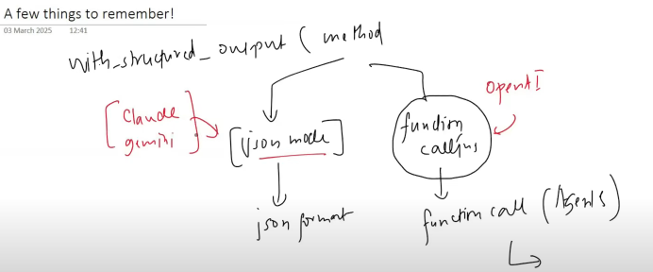

In **with_structured_output ()** function a parameter is available named (method). You choose **json method** when you have to get answer in JSON, and you can choose **function calling**, when you have to call some function/tools after getting response from model.

**Topic: 1.6.** **Output Parsers**

**Output Parsers:**

*“Output Parsers in LangChain helps to convert raw LLM responses into structured formats JSON, CSV, Pydantic models, and more. They ensure consistency, validation and ease of use in application.”*

**Note:** Output parser is normally used for models which doesn’t have the ability to produce structured output implicitly (through with_structured_output()) method, but it can also used with the models which has ability to produce structured output.

There are various kinds of **Output Parsers** in LangChain but we discuss four popular used among them.

1. Str Output Parser

2. JSON Output Parser

3. Structured Output Parser

4. Pydantic Output Parser

**Note:***We don’t learn about* ***Chains*** *till now, but* ***Output Parsers*** *works seamlessly with* ***Chains*** *with minimal implementation so we will use* ***Chain’s Approach****, rather than normal implementation with more lines of code. And Chains has very simple implementation so it will not make any hindrance in learning*.

**1. StrOutputParser**

**StrOutputParser** is the simplest **Output Parser** in LangChain. It is used to parse the output of a LLM and return is as plain string.

* So there is a question arise as we know that when we write (result.content) so it also gives output as plain string which we were doing till now. So why we now use StrOutputParser. This question can be understand through below example.

**For example:** Consider a scenario in which user type some topic and LLM gives detailed report of it then this detailed report passed to 2nd LLM which summarized it in 5 lines.

**(Code with *result.content* and with no *Chains.*)**

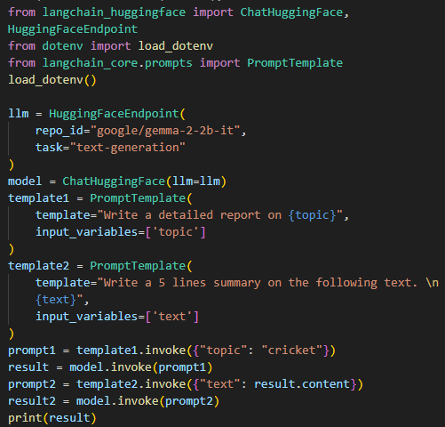

In this implementation you have to manually do all the work, like 1st create prompt1 from template1, then invoke model and get result from model, then generate prompt2 from template2 with result of prompt1 and then invoke model with prompt2 and get result of it then print, all of the work is manual.

(Code with **StrOutputParser** and with **Chains)**

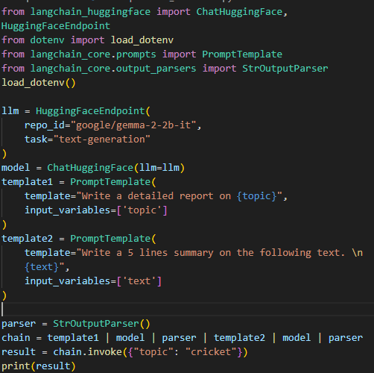

As **output parsers** works well with **chains**, so we first create a parser (StrOutputParser) then make a chain, of all the work which was done above manually, like first template1 is made through topic by (chain.invoke()), then result of **template1** becomes input to **model** which will give **detailed report** which become input for **parser,** that parse it in plain string which become input of **template2**, template2 formed and become input of **model** which **generates summary** and give output which becomes input to **parser** which parse it result in string and provide **result** so all of this manual work done in one line through chain.

***That’s why I mentioned above that output parsers works very well with chain with minimal code.***

**2. JSONOuputParser:**

**JSONOutputParser** is used to parse the output of a LLM and return is in JSON format.

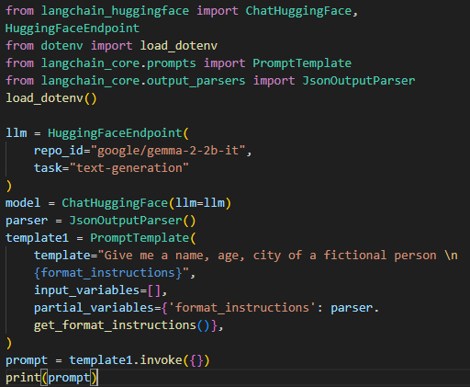







**get_format_instructions()** function give information about how the response should be written,

and **partial variable** is defined before runtime, in contrast of input_variables which defined on runtime.

**Now working with JSONOutputParser**

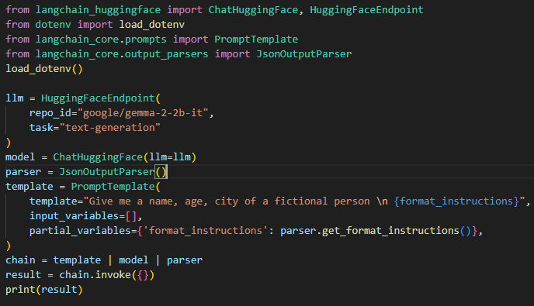



But there is one problem with JSONOutputParser that you cannot **enforce schema** (means the JSON should contain (name, city, gender) etc. in it). Means JSON result is in flexible schema as per understanding of model not yours.

**3. StructuredOutputParser**

StructuredOutputParser is an output parser in LangChain that helps extract structure JSON data from LLM response based on predefined field schema.

It works by defining a list of fields (Response Schema) that the model should return, ensuring that the output follows a structured format.

**Working with StructuredOutputParser**

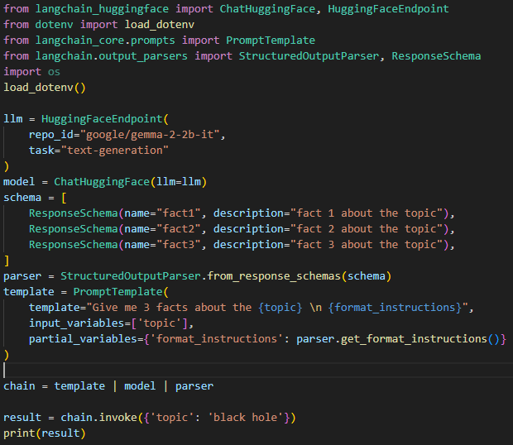



There is one problem with **StructuredOutputParser** that it helps to enforce schema but not able to do **Data Validation** (means it enforce schema as (name, age, city) and if you want that name should be string, age should be int, and city should be string) but Structured output parser does not ensure in any way that this validation should be done as it can return age as (**35 years** instead only **35**).

**4. PydanticOutputParser**

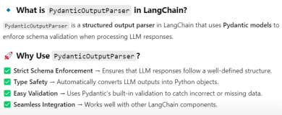

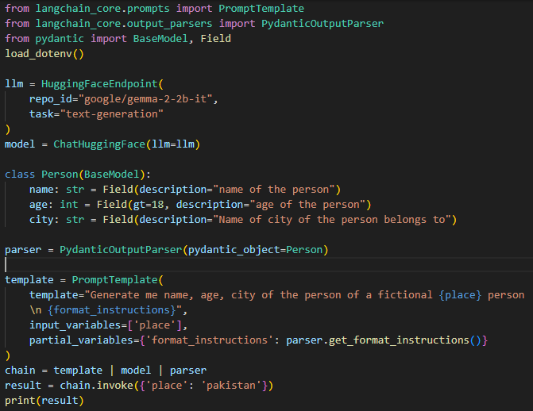



**Topic 1.7:** **Chains**

**Chains:**

A Chain is simply a sequence of steps (components) linked together, where the output of one step is used as the input for the next.

It’s like a pipeline that can connect things such as prompts, LLM calls, API requests, or data processing steps, so you can build more complex workflows than a single LLM call.

Example:

1. Take user question →
2. Search the web for information →
3. Summarize the results →
4. Give final answer to the user.

That’s a chain — multiple actions connected in order.

**Example 1: (Simple Chain)**

Consider we take country from user as input and give result about its capital.

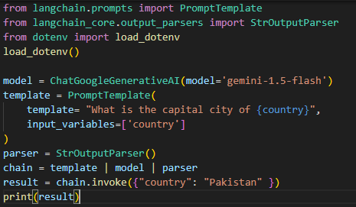



In this example, we first provide input to template through which a complete template is formed then automatically through chain this output becomes input for model and model return answer which became parse by parser and give the result.

**Example 2: (Sequential Chain)**

Consider we first take input from user a topic, a topic goes to model which generate its detailed report and then the report will provide to again model to generate 5 points summary from that report.

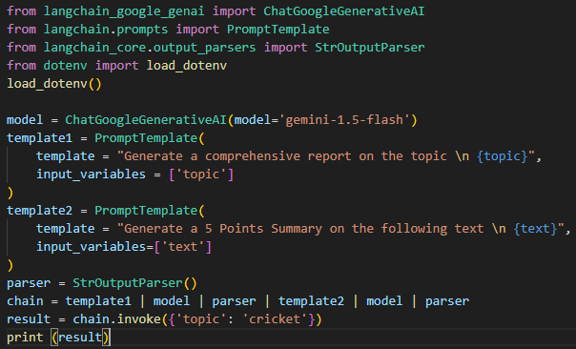

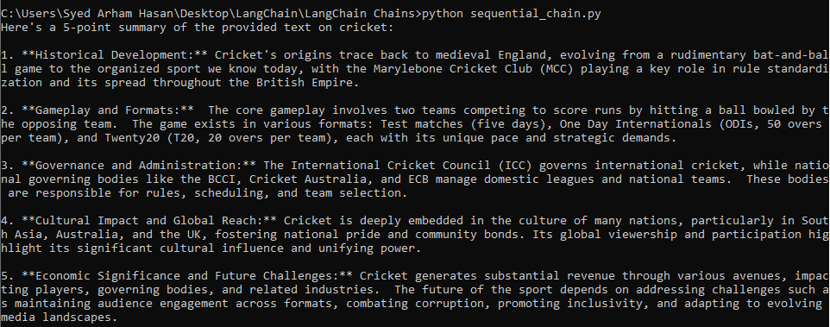

So, in above code we first made template for report generation by providing topic about cricket, then prompt becomes input to model which generate its report and give report to parser which parse the result and provided this result to 2nd model which generates its point summary and parser parse the result and then result has printed.

**If you want to visualize the *chain flow* so you can do by following code:**



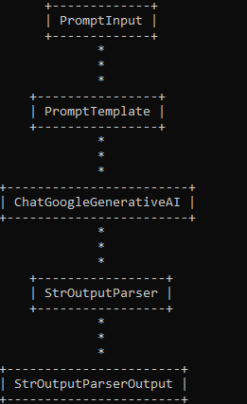

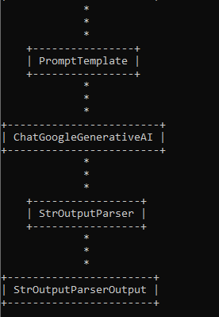

**Example 3: (Parallel Chain)**

Consider a User Provided us a lengthy text on some topic like (Linear Regression, etc.). We want to Generate Notes and Quiz From that text. Now understand how it can be done through Parallel Chains.

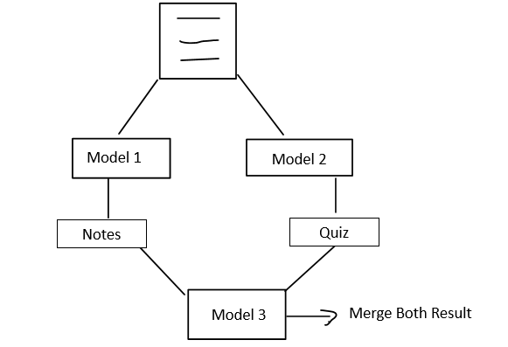

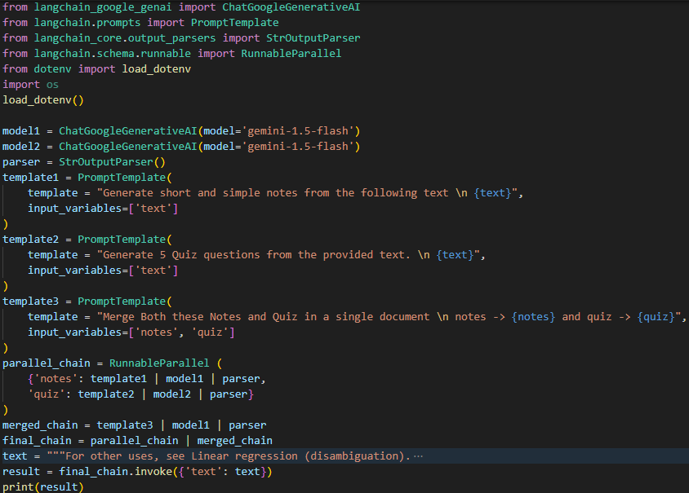

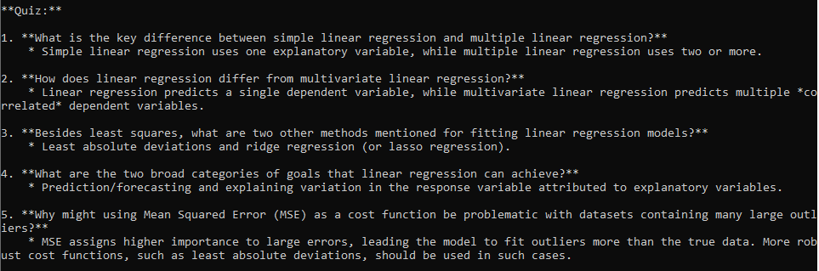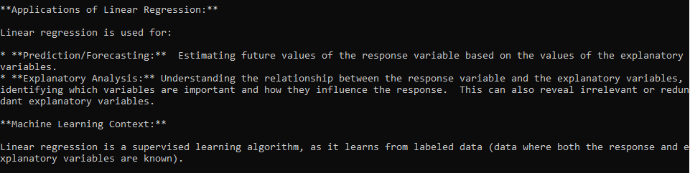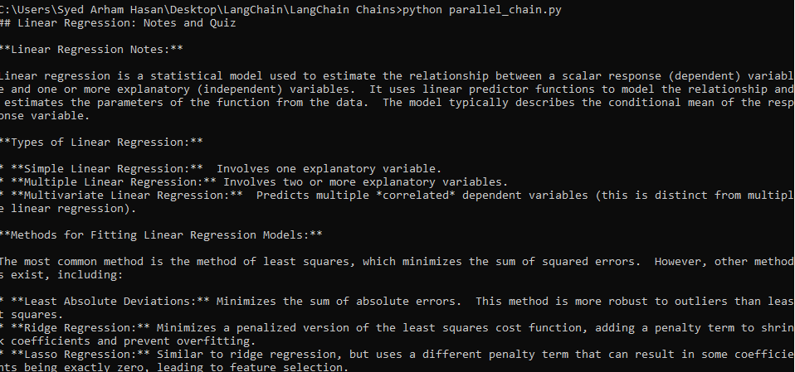

First, we made 3 templates, and then made a **parallel_chain,** Parallel Chains can be made in LangChain through **RunnableParallel (Runnable will cover in details in next lecture).** So first we cover parallel chain then we cover merged chain part and then we combine both chain to made final chain (in which parallel chain result will be acts as template3 for merged chain) to produce result.

**Example 4: Conditional Chain**

Consider a user a provide feedback and we have to give response according to feedback (sentiment).

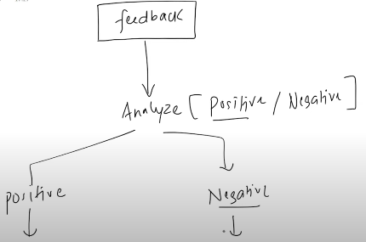

In Conditional Chain only one chain will execute (either positive or negative).

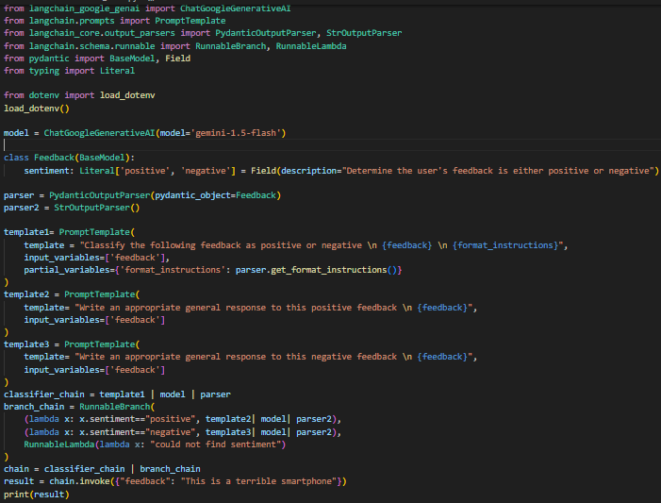



As classifier chain provide result (sentiment=positive or negative) so get output sentiment from variable and provide this to input as other chain that is in branch, we **lambda function.** Through **RunnableBranch** (We can make conditional branches, with if, else, default), in default there should be a chain provided so we use **RunnableLambda** to convert lambda function into chain.

**Note: We will learn in details about *Runnables* in Next lecture so here you should only understand purpose of these functions only to implement functionalities.**

**Topic: 1.8.** **Runnables & LCEL (LangChain Expression Language)**

**Runnables**

First, let’s understand why the need for **Runnables** arose.

In November 2022, when ChatGPT was released, many developers started building LLM-based applications such as PDF readers, chatbots, and AI agents. Later, when Google and Anthropic also released their LLMs, the LangChain team decided to create a framework that would make it easier for developers to build LLM applications.

They noticed that these APIs had different, non-standardized implementations. To solve this, they standardized them in LangChain with minimal code changes by introducing **Models**. Over time, the LangChain team also realized that many complex components in LLM-based applications—such as retrievers in RAG applications or PDF loaders—were being reused in different projects. To save development time, they created ready-made components that could be used with just one line of code.

Later, they identified another pattern: in almost every LLM application, the process was the same—create a prompt from a template, pass it to the model, and manually handle the response. LangChain automated this by introducing the **LLMChain**, where developers only need to provide the LLM and the template. The chain automatically generates the prompt, sends it to the model, and returns the result.

Similarly, in RAG-based applications, a user query is embedded, searched in a vector database, relevant results are returned, and then both the query and retrieved data are passed to the model to generate a final answer. LangChain automated this process through RetrievalQA.from_chain_type, where you simply provide the LLM and the retriever.

However, LangChain didn’t initially anticipate the huge number of chains that would be created by combining various automated components. For new developers, this made learning more difficult because each component behaved differently and exposed its functionality through its own methods. This lack of standardization often required extra custom code to integrate components, resulting in heavier codebases.

To address this, LangChain introduced **Runnables**, which standardize all components so they can be integrated in the same way. Every component now exposes common methods like .invoke(), making it easier to connect components into chains while greatly reducing custom logic.

* **What is Runnable?**

1. **A unit of work**
   1. Takes input
   2. Process it
   3. Give Output
2. **Common Interface**
   1. invoke()
   2. batch ()
   3. stream()
3. **Connect with each other**

**R2**

**R1**

* 1. Output of First become the input for second automatically. You can create any complex workflow through it.

1. **Complex workflow made by connecting different Runnables also a Runnable.**

For Example:

invoke

invoke

invoke

parse

predict

format

parse

llm

prompt

Before introducing Runnables all components behave independently in their own way and have different methods, after introducing runnables all components now have a common method like (invoke), and behave in a same manner through invoke function which helps in integrating theses components in form of chain. So basically behind the scene **an *abstract class formed of Runnables and all these components inherit the Runnables class so they must have to implement invoke function and the same functions which they performed through their own functions like (format, predict, parse) now done through (invoke) also****.*

* **Types of Runnables:**

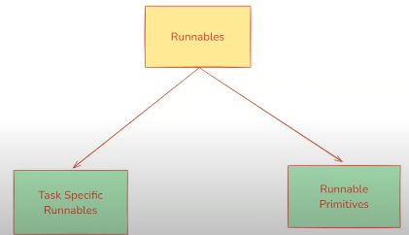

**Task Specific Runnables:**

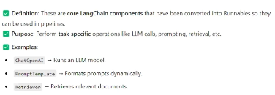

**Runnables Primitives:**

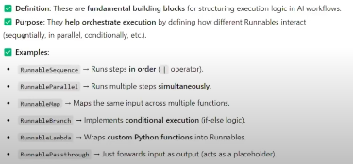

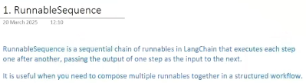

**For Example:**

Consider a scenario in which we take a topic from a user and generate a joke for the user on that topic.

Code:

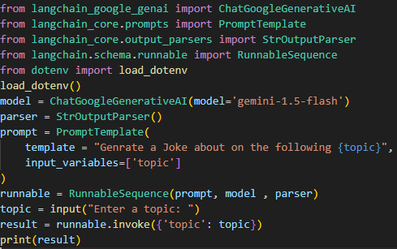

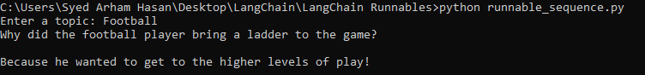

**We can create longer sequential chains as possible for example add other things that after getting joke model should also explain this joke.**

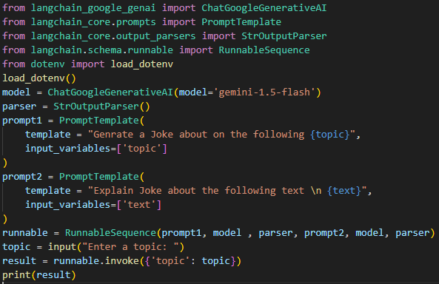

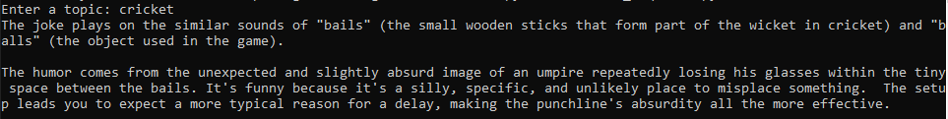

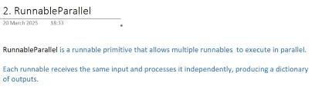

**For Example:**

Consider we take input form user about a topic and model1 generate tweet about this topic and model2 generate LinkedIn Post about that topic.

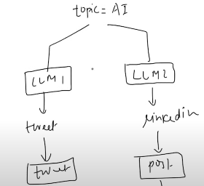

**Code:**

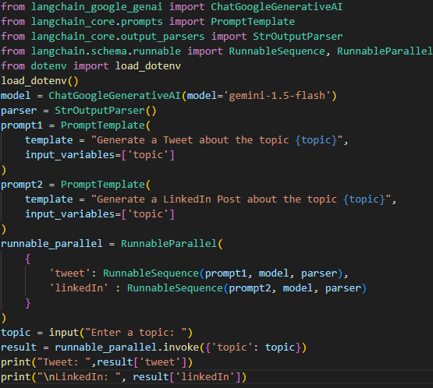

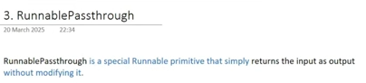



**Means take same input and produces same output (like input(z) -> output(z))**

So, a question come in mind why we use this, if this runnable do nothing but just passing. This question will be clear through below example.

**For example:**

In the above Runnable Sequence example, we take a topic from the user and generate an explanation of a joke based on it. When we take a topic from the user, the model provides only the explanation as the final output. However, if the requirement is for the model to return both the joke and its explanation, this cannot normally be done through a RunnableSequence, because it only returns the result of the last component in the chain. We can fulfill this requirement using the method shown below.

RunnablePassThrough (joke obtained)

prompt1 🡪 model 🡪 parser (joke obtained)

prompt2 🡪 model 🡪 parser (explanation obtained)

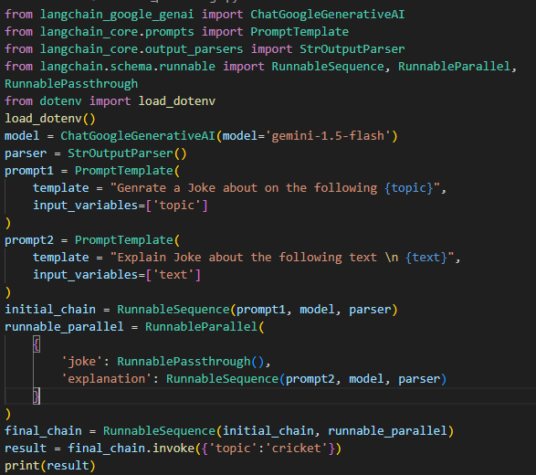

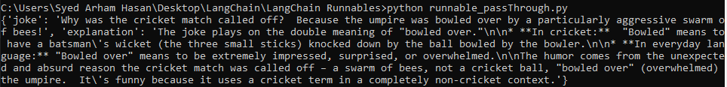



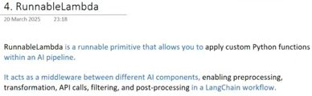

For Example:

Consider an example in which we take topic from user and will do two things first we generate a report through it and 2nd we count no. of words in a report through **RunnableLambda (by applying custom python function).**

**prompt 🡪 model 🡪 parser (report obtained)**

RunnablePassThrough (report obtained)

RunnableLambda (custom word counter) (words obt)

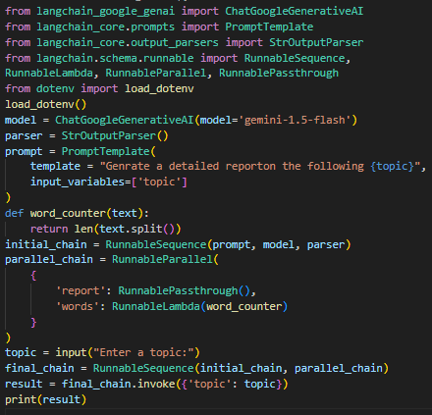

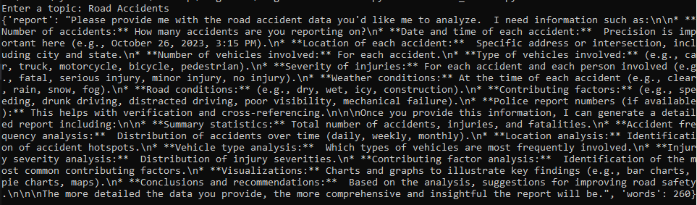



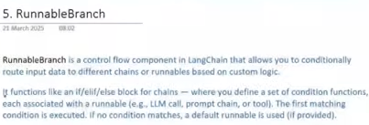

For Example:

Consider an example in which we take input (topic) from user and generate a report of it *if the report is greater than 300 words then model will summarize it, else model give report as it is.*

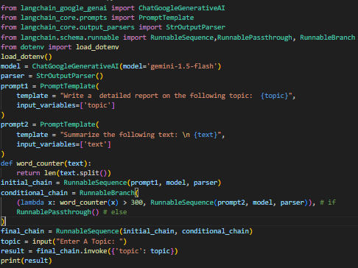

***Else Condition run:***

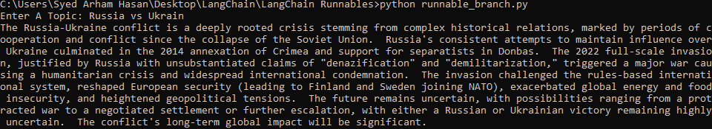

*If I make limit 1000 so maybe if condition runs.*

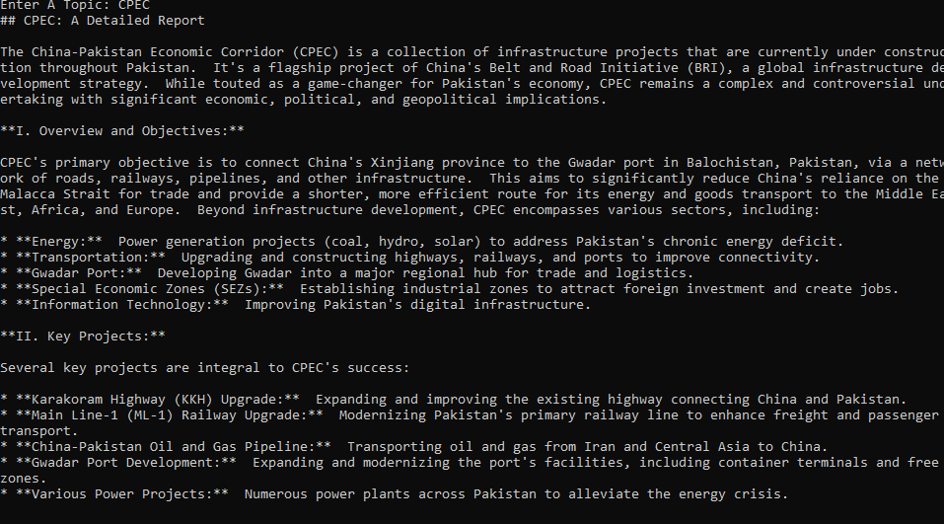

**LCEL (LangChain Expression Language):**

In the Runnables chapter, you may have noticed that RunnableSequence is used most of the time, as it is a core component in many applications. To simplify its syntax, the LangChain team introduced a “pipe” (|) method for RunnableSequence. Instead of writing **RunnableSequence(prompt, model, parser)**, you can now write it as **prompt | model | parser.** This simplified syntax is known as **LCEL (LangChain Expression Language)**.

**2. RAG**

**RAG (Retrieval-Augmented Generation)** is a technique that combines information retrieval with language generation, where a model retrieves relevant document from a knowledge base and uses them as a context to generate accurate and grounded responses.

Benefits of Using RAG:

1. Use of up-to-date information
2. Better Privacy
3. No limit of document size

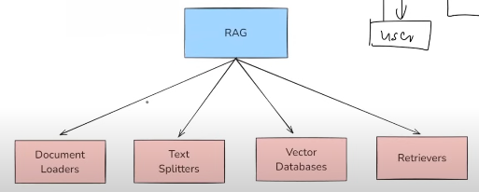

**Topic: 2.1.** **Document Loaders**

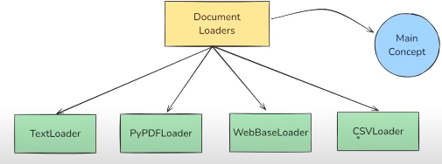

In this chapter we will learn about main concept of Document Loaders and learn working of four Document Loaders out of many.

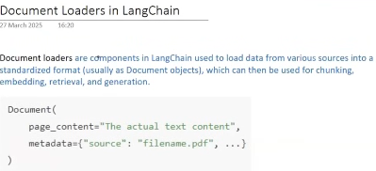

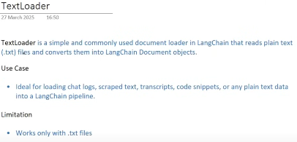

**Code:**

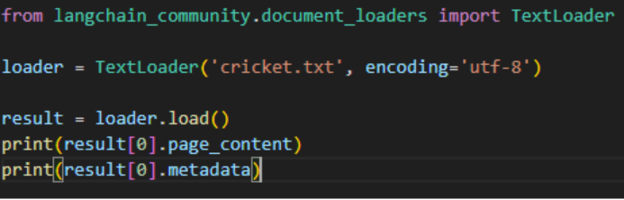

Normally loaders load result in form of **list** which can contain multiple documents, in this case we load only a single file so we can access its 0th (first) element in which our document is present.

**Output:**

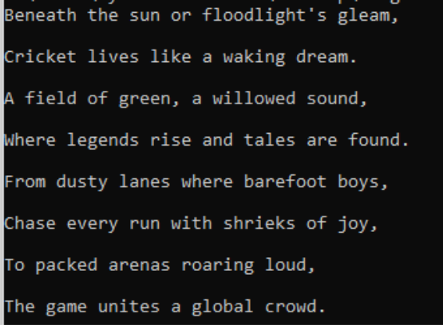

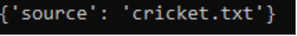

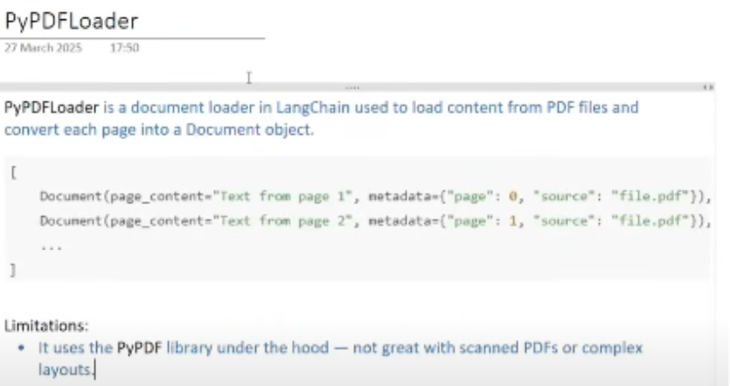

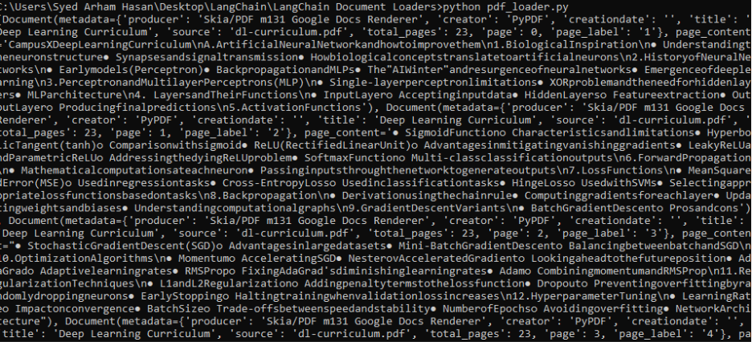 

I have only taken screenshot of some pages but in original 23 pages printed.

If you want to read content of any particular page so you can access through index.

For example:

1st page can be access through **docs[0].page_content**

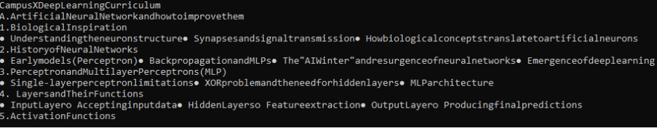

There are multiple types of PDF Loaders in LagChain

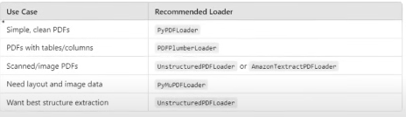

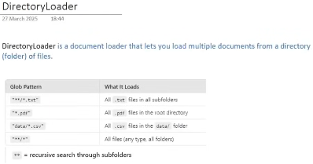

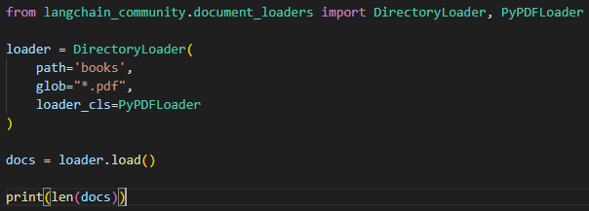



In Directory Loader First you define **directory path**, then which types of files will be load from directory like **\*.txt, *.pdf**, then if pdf so from which loader pdfs will be load like **PyPdfLoader**.

**The above result shows that total pages in All PDFs of Books directory are 326.**

If you want to read content of any particular page so you can access through index.

For example:

2nd page can be access through **docs[1].page_content**

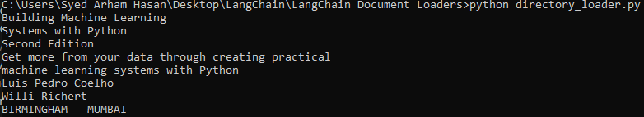

**But there is a problem with this load function, consider if a directory contain 10-12 PDFS with 1000+ pages so all of the pages first loaded in memory and then available for execution, so it takes a lot of time and also memory may become full through this action, so to overcome this problem we use “*lazy_load”.***

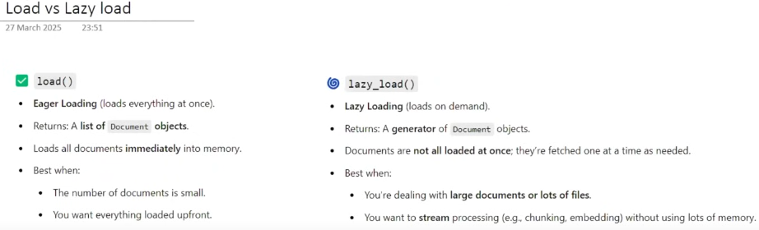

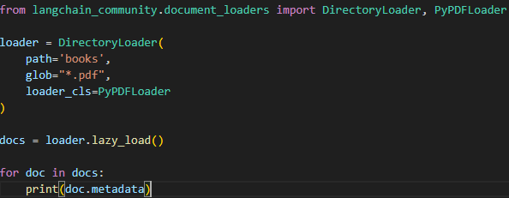

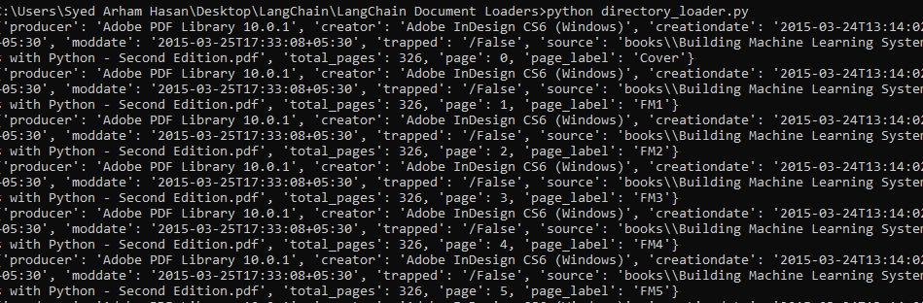

**Through lazy_load one document comes to memory and its metadata print and remove from memory.**

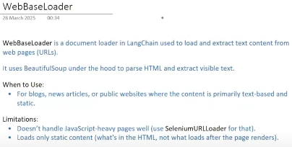

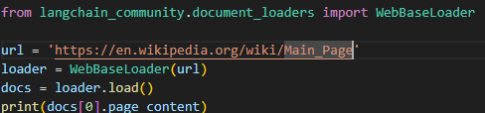

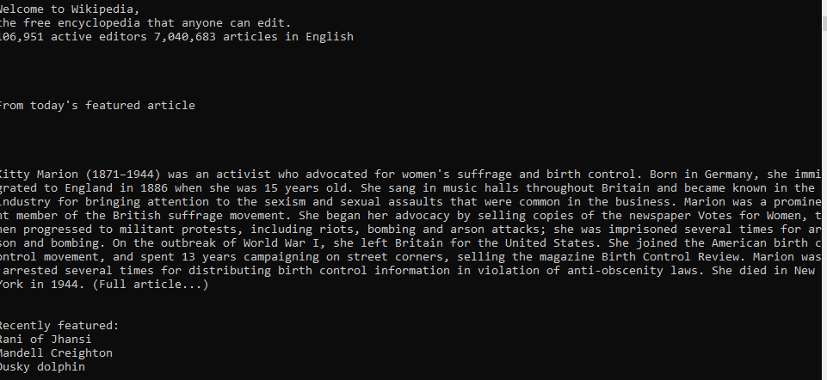

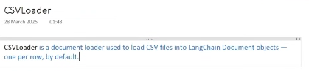

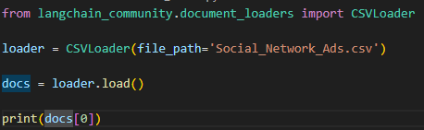

**Through indexing you can access any row.**

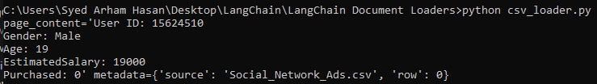

**Now we cover some of the popular loaders, there are lot of loaders you can learn through LangChain website and use them according to your project requirement, or you can also build your custom loader according to your requirement.**

**Topic: 2.2.** **Text Splitters**

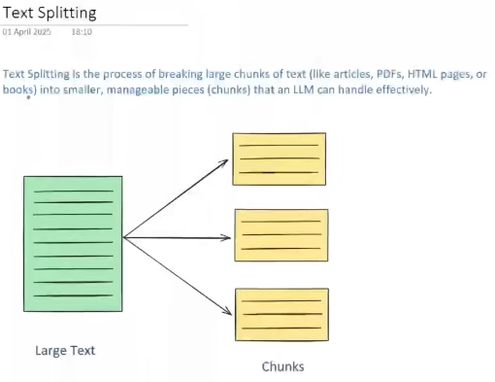

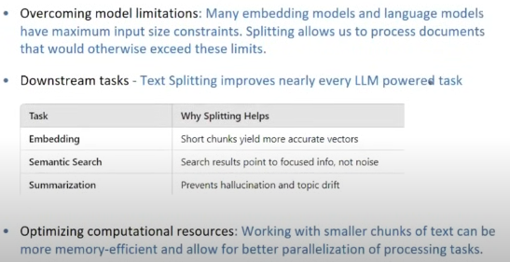

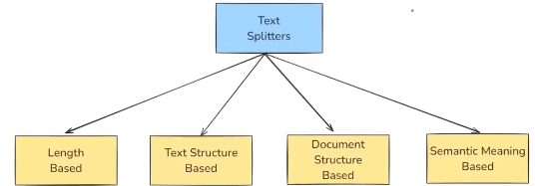

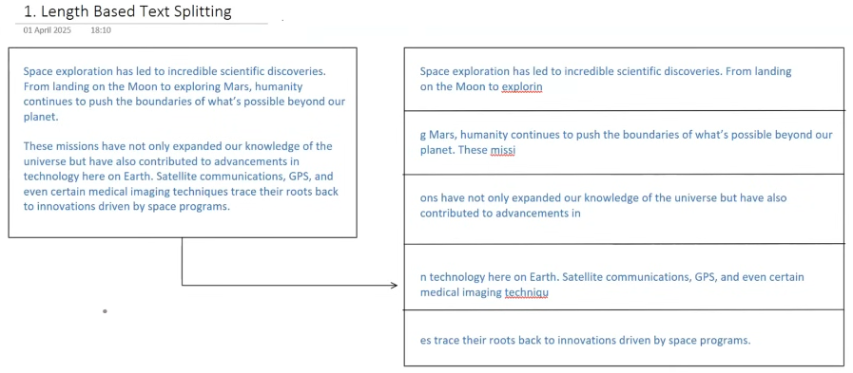

In length-based splitting you have to define what will be the chunk size of each chunk (i.e 100 characters).

**For analyzing text splitting through animations you can visit** [**chunkviz**](https://chunkviz.up.railway.app/)**.**

* *But there is a problem with length-based splitting that while splitting, it does not see about any grammar, linguistics, spelling, context, it just only splits when given chunk size limit reached, whether the spelling of word completed or not.*

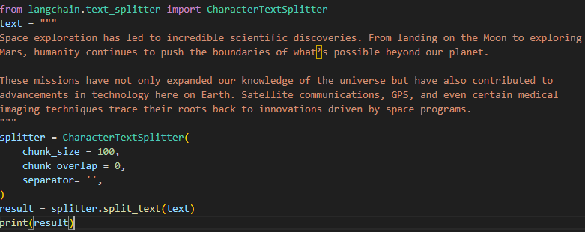

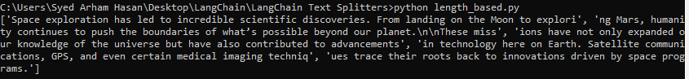

*chunk_size = (define chunk size)*

*chunk_overlap = (means each chunk should have which number of characters of next chunk)*

*separator = ‘’ (shows that chuck will be separated through which character or something)*

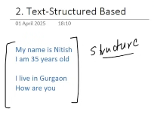

Normally a text can be structured in a following way that, first we organize our text in form of paragraphs, in paragraphs we organize text in form of sentences, in sentences we organize our text in form of words.

So, the techniques which can helped for this kind of structured based splitting is called ***Recursive Character Text Splitting***.

In this technique we defined some separators that helps in splitting like (**\n\n for paragraphs**, **\n for sentences**, **‘(empty space)’ for spaces(words**), and **(‘’) (nothing) for characters**)

So, these techniques first try to make chunks on paragraph level, if its not possible, then try to make on sentence level, if it is not possible so try to make chunk on words level, and if it is not possible so at last make chunk on character level.

**For example:**

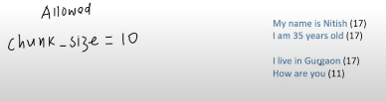

So first it tries to break this text in form of paragraphs as it sees \n\n between **old and I,** so it splits it from there.





But left chunk of 34 characters and right chuck of 28 characters and allowed size is 10 so splits it through sentences.



Still sentences sizes is exceed allowed limit, so it further breaks in words.

[My] [Name] [is] [Nitish] [I] [am] [35] [years][old] and same others

2 4 2 6 1 2 2 5 3

Now the techniques try to optimize the chunks by making it possible of allowed size like merging possible chunks

[My Name is] [Nitish] [I am 35] [years old] [I live in] [Gurgaon] [How are][you]

10 6 7 9 9 7 7 3

So resultant chunks will be these above.

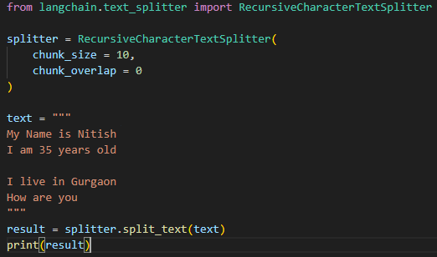



Result is a slightly different of chunk 1 and 2 from the result above we just described, but on [chunkviz](https://chunkviz.up.railway.app/) the result is same as above we described.

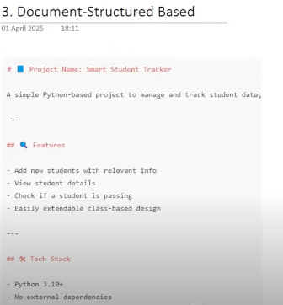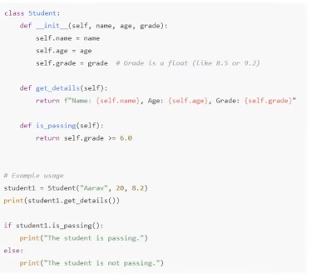

In normal text-structured splitter have some separators through which they can identify from where the text should split like **\n\n** or **\n, etc.** In Document-Based structured we can have documents of many different types, like some markdown, or some kind of codes of some language, so they have their different separators through which they splits like for code separators may be (class, def, loops) etc.

**For Markdown the splitters are:**

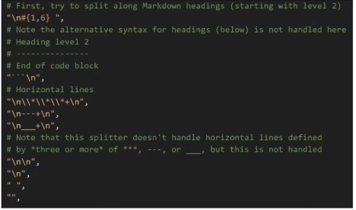

**For Python the splitters are:**

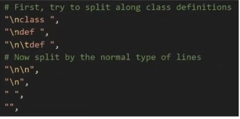

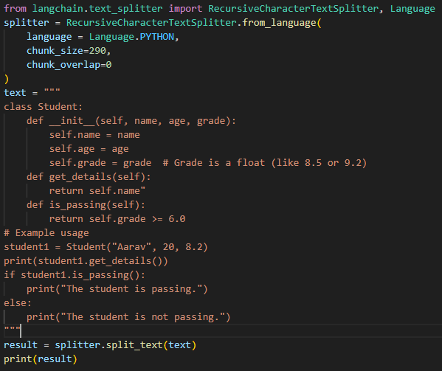

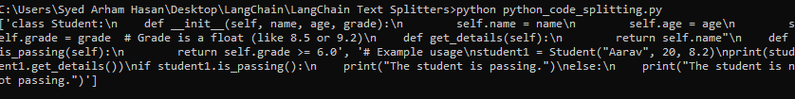



There is a support of multiple languages like (Java, JavaScript, PHP, etc.)

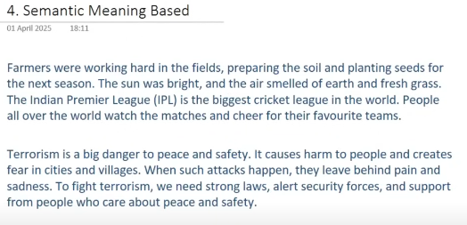

In Certain Scenarios, like above text, both length and structured approach fails, because first paragraph combines two topics, one of farmer and other of IPL, and 2nd on Terrorism, so through both above techniques we will not be able to gain proper contextual meaning of above text.

For above text chunks should be [Farmers were …….. fresh grass] [The Indian ………..teams] and [Terrorism is ………. Safety]. through structured approach we could only divide it into 2 chunks but not 3.

**Working:**

In semantic meaning–based splitting, the text is first divided into sentences, and their embeddings are generated using an embedding model. Then, the similarity between successive sentences is measured. If the similarity between two successive sentences is low (or if the standard deviation—or any chosen threshold type—of similarity is greater than 1-or any threshold breaking amount), it indicates a possible topic change. This point is then considered a breaking point, and the text is split from that sentence to create a new chunk.

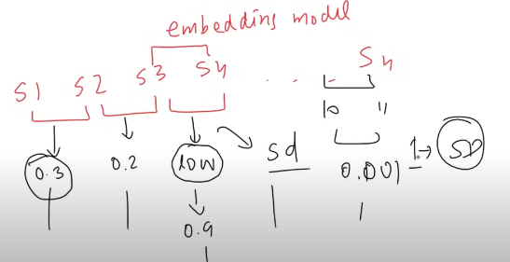

But this concept is new and not much that accurate as others, it will maybe become accurate in future soon.

**Code:**

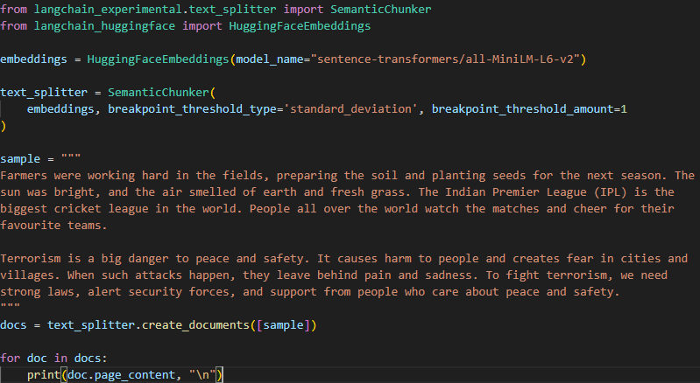

**Output:**

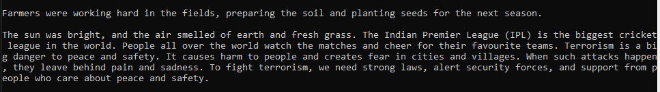

**Topic 2.3:** **Vector Stores**

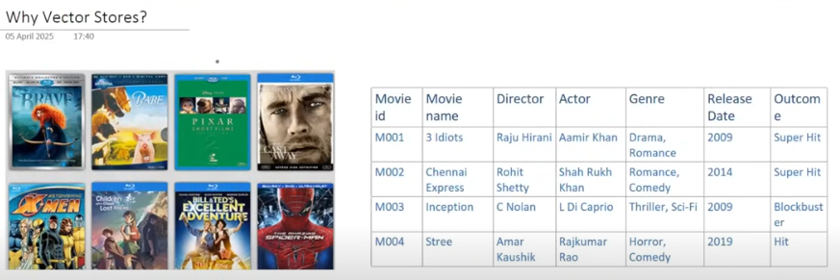

Consider that you want to make a website where you list all movie information, similar to IMDb. The process of building this application would involve creating a database where you store movie details, and then setting up an API through which data is fetched from the database and displayed on the frontend.

Now, if you want to add a movie recommendation feature to this app, the recommendations can be achieved in various ways. One approach is keyword matching between movies.

For example, suppose you have two movies (m1 and m2). You would compare them based on different keyword parameters such as director, actor, genre, etc. If these parameters match, you would recommend the movies to users as related.

However, there is a problem with this approach. Consider the example below:



If I have seen **My Name Is Khan** movie now, so our recommender system will suggest me then **Kabhi Alvida Na Kehna** because (Director is same, lead actor is same, year of release almost with slight difference) but they have completely different story line and different concept movie. So, movie recommender system will not perform well in many cases and product correct outputs.



And similarly, two movies like the ones above would never be recommended to each other because they do not share any keyword similarities such as director, actors, or year of release. However, they may still have the same storyline, context, or concept.

In conclusion, the idea of keyword matching is not very effective because it often fails to produce accurate results. However, we have another idea: if we compare the plots of movies with each other, the recommendations could be more meaningful. Through APIs, we fetch the movie plots and store them in the database for this purpose.

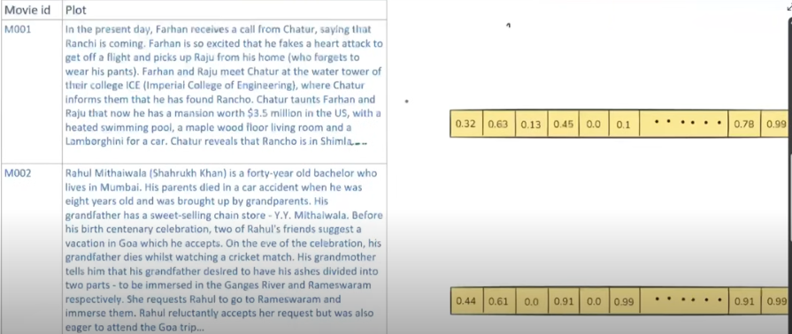

Now, we need to build a functionality that can compare movie plots and generate a similarity score, which can then be used to categorize and recommend movies to users. However, this idea is not as simple as it sounds, because comparing two pieces of text and understanding their semantic meaning in order to determine similarity is not an easy task.

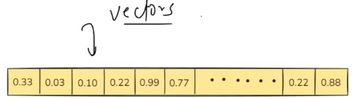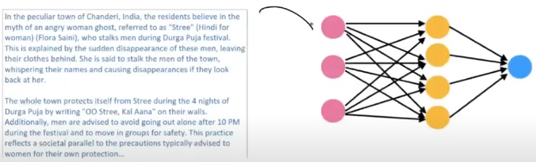**Deep Learning, solves this problem of comparison of texts based on sematic meaning.**

A text is provided to a neural network, which converts it into **vectors (embeddings)** (a series of numbers) that represent the semantic meaning of the text. Once the text is converted into numbers, finding similarity becomes much easier compared to working directly with raw text.

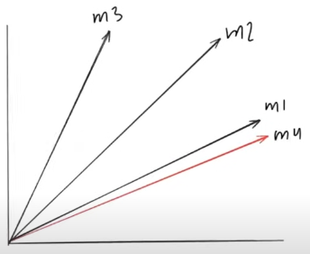For example, consider that these vectors have 128 dimensions (each vector contains 128 numbers). If we plot them in a 128-dimensional coordinate system, we can then measure how close they are. Using methods like **cosine similarity** or **angular distance**, we can determine which movies are semantically similar. Movies with a high cosine similarity (or a low angular distance) will be considered similar and can be recommended to each other. (like m1 and m4 are similar to each other).

To Implement this kind of functionality we will face 3 major challenges.

Consider we have 1000K plots of movies in our database.

1. To convert all the plots into embedding vectors
2. To Store huge amount embeddings
3. Intelligent Semantic Search (Because if you want to compare any embedding with other vector so you have to compare with 1000K embeddings in database.

**So, Vector Stores helps us to cater these challenges.**

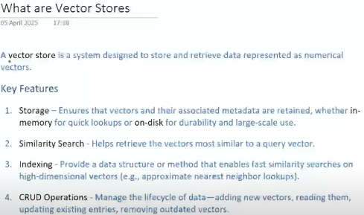

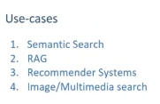

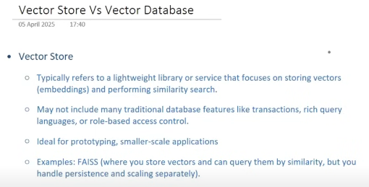

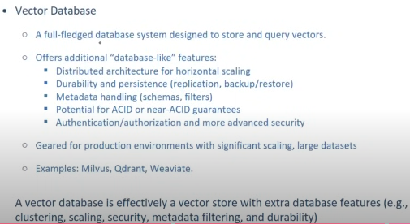

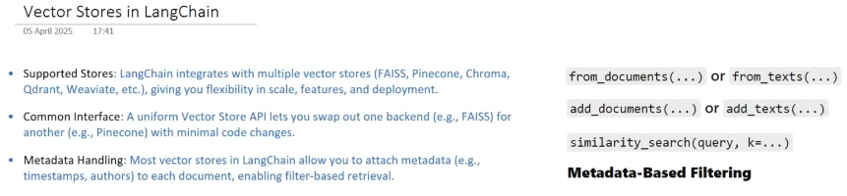

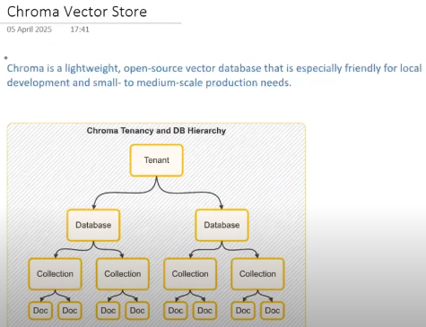

All of the working related to vector stores including (creating vector store, adding documents, similarity search, filtering, updating, deleting) can be view through this Google Collab [Link](https://colab.research.google.com/drive/18yBhF2GBOHimLr8-Dh6wRBZ0Ptp-sqJv?usp=sharing)

**Topic: 2.4.** **Retrievers**

**What are Retrievers?**

A retriever is a component in LangChain that fetches relevant documents from a data source in response to a user’s query.

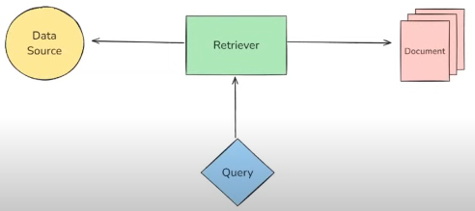

There are multiple types of retrievers in LangChain, which are typically categorizes on the basis of two things.

1. Source (through which data will be retrieved)

1.1. Wikipedia Retriever

1.2. Vector Store based Retriever

2. Searching Strategy (through which it will fetch relevant documents)

2.1. Maximum Marginal Relevance (MMR)

2.2. Multi-query

2.3. Contextual Compression

**1. Source Based Retrievers**

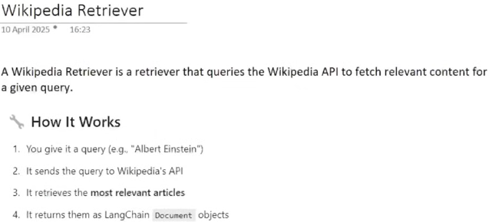

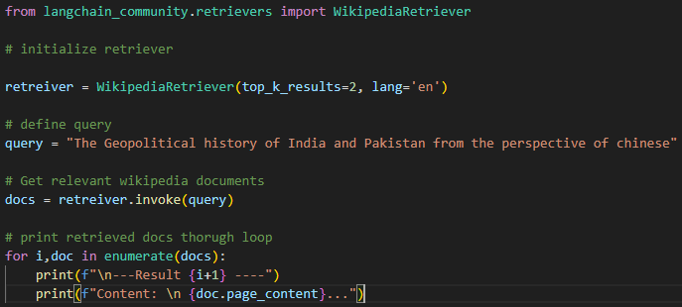

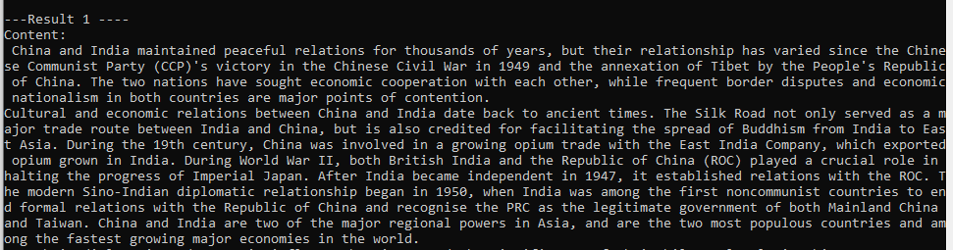

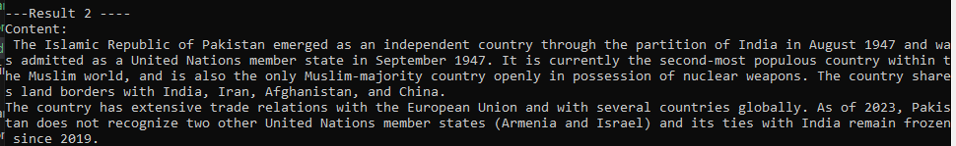

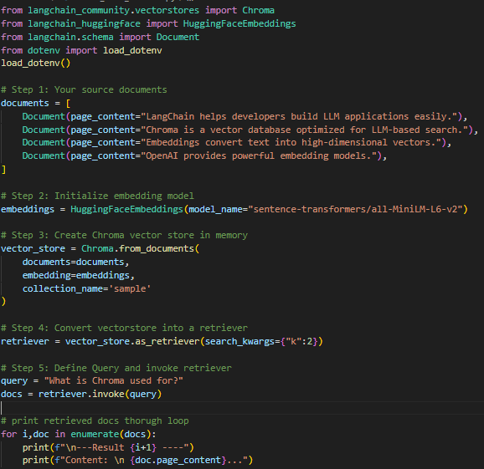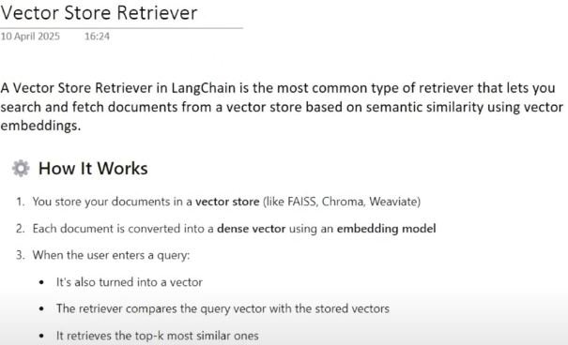

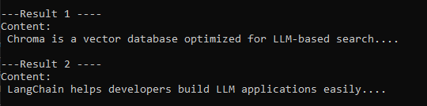

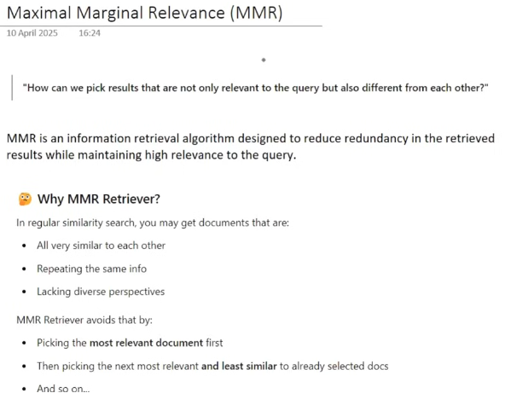

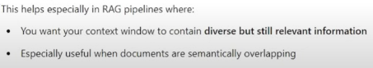

**For example:**

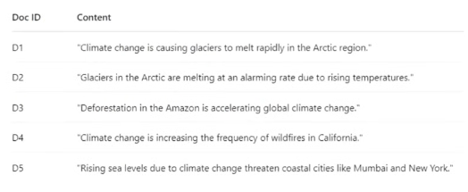

We have these document in vector store, and a user gives query about thr **adverse effect of climate change.**  So normaly similarity seach retriever fetch the relevant documents is as follows.

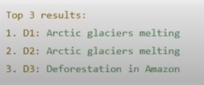

Means D1 and D2 where the context od docs about the **Arctic glaciers melting** and then **Deforestation**  in amazon, but the problem is both D1 and D2 have same context and repeating the same info. It would be better that the result provided to user in a way that it should be relevant to query but not redundant and giving same context and same info as other documents like below.

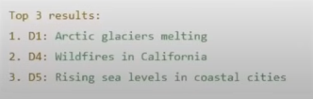

In this picture, result is relevant to query but also different with each other.

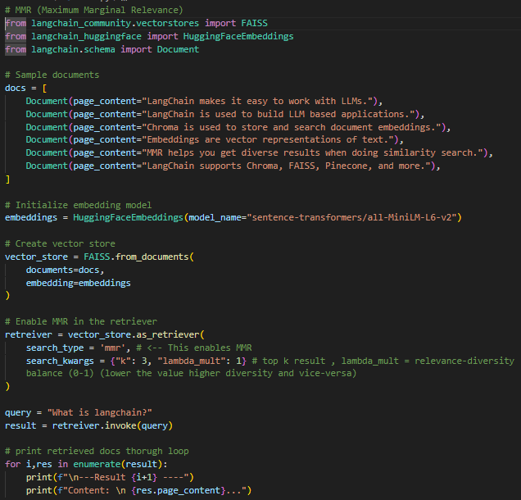 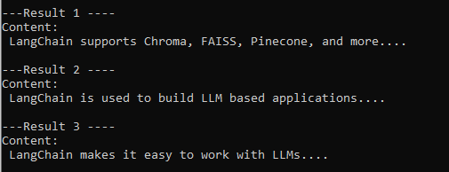

**When lambda_mult set to 0.5**

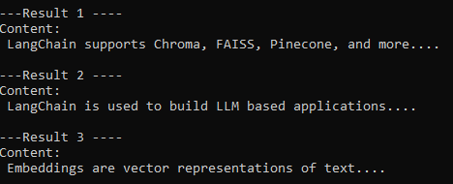

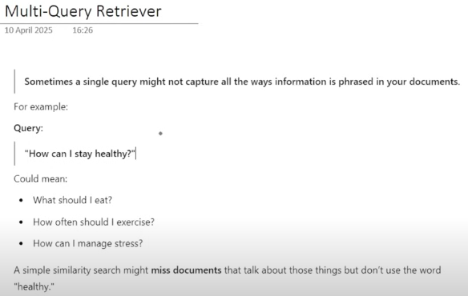

**As shown above that the query is unambigious by user which can have multiple meanings like, so by performing single similarity search it will not cover these context.**

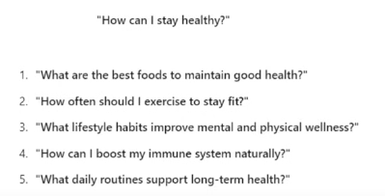

**How this retriever works:**

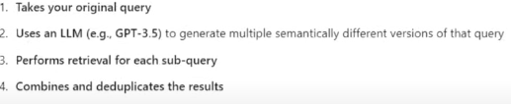

retrievers

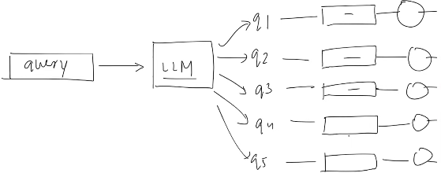

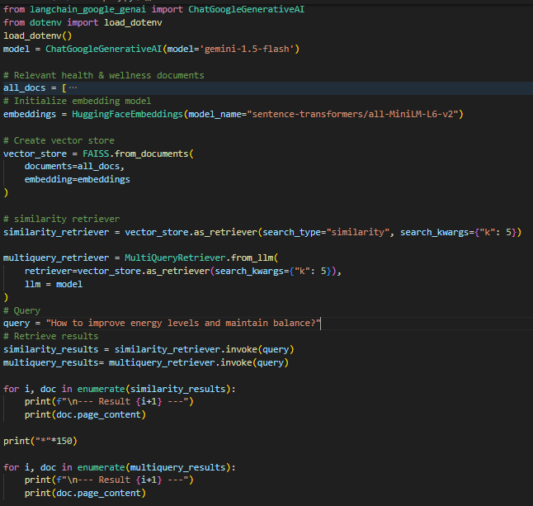

**In above code we have compared normal simialrity search and multi-query search.**

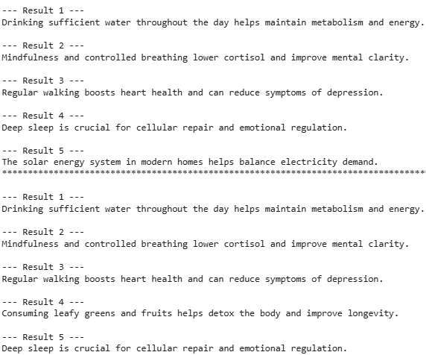



**So normal similarity search give one wrong result and confuse about the topic and give one wrong result (about solar system) whereas multiquery understand well and give all result according to health and nutrition.**

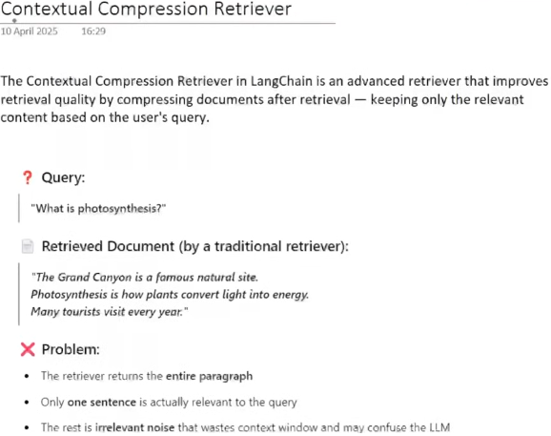

Because during text splitting there may be a possiblity some chunk that can be present as above in example due to wrong splitting and context of some other paragraph merged with this chunk.

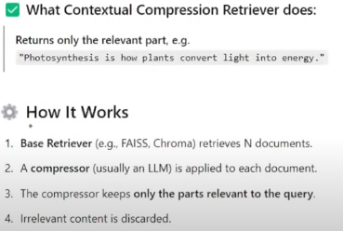

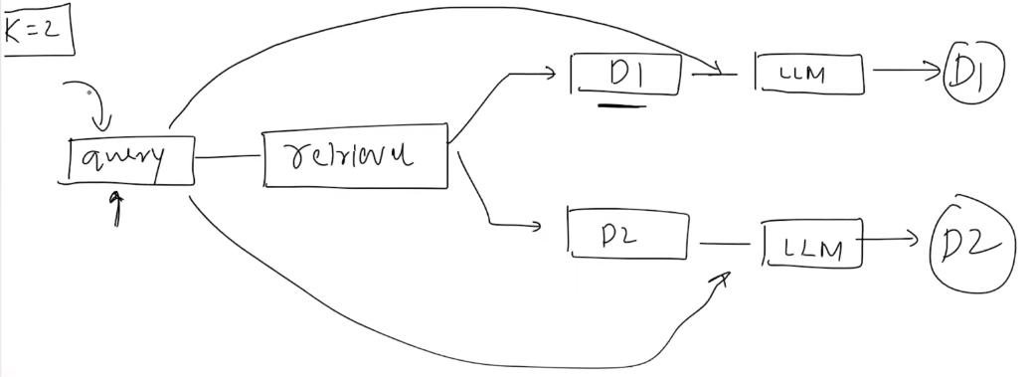

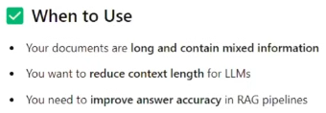

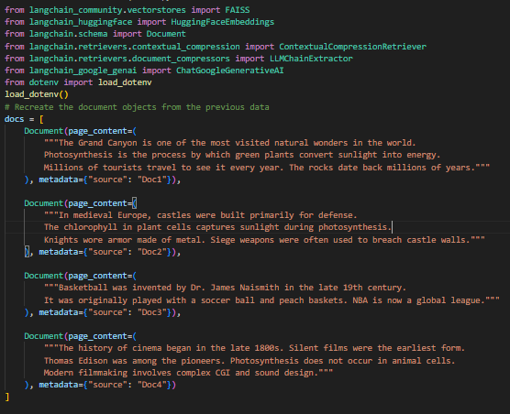

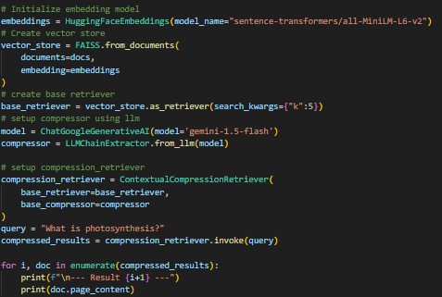

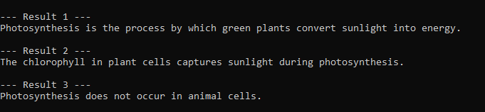

**So in above code we have documents that have mixed context but our contextual compression retriever compressed document according to our query and gives us result.**

**Topic 2.5:** **RAG in Detail**

**In above 4 chapters we have learnt about the 4 main components of RAG which helps in building RAG application now as we learnt about those topics, we can start developing RAG applications.**

**First we will understand about the why, what, and how of RAG in detail, then start developing application.**

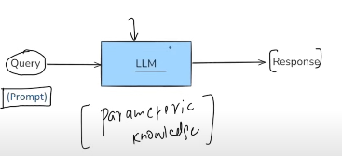

LLMs are large neural networks built on the Transformer architecture. They are trained on vast amounts of internet text during their pre-training phase, but they do not store this data in a database. Instead, they store knowledge in the form of **parameters**—numerical weights that capture patterns in the data, similar to neurons in the brain. This is called **parametric knowledge**, meaning that a higher number of parameters allows the model to capture more patterns from the training data.

If you want to access this parameteric knowledge, so you can interact with LLM through prompting, you provide some query and LLM tries to undersatnd query and generate results word by word thorugh its paramteric knowledge.

But, there are three challneges/lacking in this normal query approach to LLMs.

1. **They cannot provide any answers related to your private data** (because it does not see your private data during its pre-training phase).
2. **They cannot provide up-to-date results like current affairs, recent incident** (because all LLMs have their cut-off pre-training date means last date on which it was trained and it cannot give information about anything after that date, *but one question arises how ChatGPT gives current (up-to-date) information,? Because it has access to search on web for searching up-to-date results.*)
3. **It hallucinates about some factual things with proper confidence sometimes, even that it was made up in reality.**

One of the techniques to solve above problems in **Fine-Tuning.**

**Fine-Tuning**  is the process in which you have to train a pre-train LLM to some specific domain with relatively smaller dataset so LLM can give quality and more accurate results about that specific domain.

We can understand through example that (**LLM** is student, **pre-training** is his 4 year education, and **fine-tuning** is the specific training giving to student when he join specific orgainzation to know how the operations of this particular organization working)

**Fine tuning can be donw through various techniques like**

1. Supervised Fine-tuning (where you give labelled data to LLM like **prompt -> result** to train about the result should have give in response to an specific prompt)

2. Continued Pre-training (unsupervised) (for example if I have to made a chatbot for my course learning platform so I provided transcript of courses to model so it understand about queries realted to courses on platform)

*Through Fine-Tuning we can solve first challenge of private or domain specific results as we can fine-tuned the model according to our data,*

*Second challenge can be solved but if our data is updated so we have to again fine-tuned model for updated result according to updated data,*

*Third challenge can be resolve as we can mention model that if they donot have result according to users’ query so give did not know message rather than hallucinating wrong result.*

**Challenges of Fine-Tuning:**

**1. Fine-Tuning of LLM is not easy task and required expensive computation**

**2. Require Proper technical expertise (like AI engineer or Data scientist) to fine-tuning an LLM.**

**3. You have to again and again fine tune the modal as specifc data updated for updated results (which also required expensive computation).**

**Another technique to solve these challenges is (In-Context Learning)**

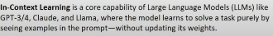

**In GPT-1, GPT-2 models are only given answer to queries according to their (paramteric knowledge) but after introducing GPT-3/4 and other new models, a things is automatically observe that these models are also able to learn to give results by providing them with some examples.**

**For example:**

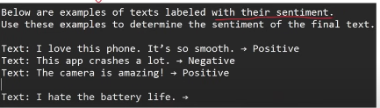

**So the model will give (Negative) result by observing few previous prompts.**

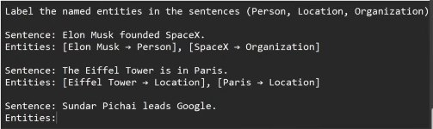

**So the model will give entities from the given sentence.**

**In-Context Learning is (Emergent Property) of LLMs**

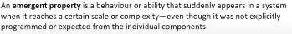

As we are providing few shot examples to get certain specifc results from model. So a question will appear that if we provide a detailed context about something of what we are asking from model, so it may give more accurate results?

**For example:**

If on a course learning platform, a chatbot is present with video lectures for users, so if users doesn’t understand something from video so it can ask chatbot about the concept, for example if user asked about **RunnableParallel** to chatbot in a **Runnables**  video so user’s query send to chatbot and explanation of RunnableParallel are on between 25-35 minute of video so we send user’s query to chatbot with 10 minutes **RunnableParallel** transcript to provide proper context to chatbot so it gives accurate and within context answer rather than sending whole video’s transcript, like below example.

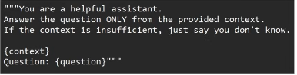

The above example I have explained to you is precisely can be called **RAG (Retrieval Augmented Generation)**

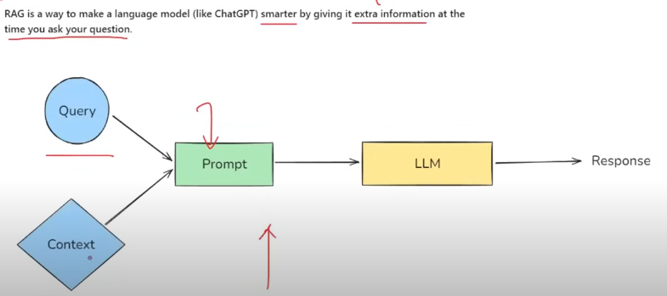

When you provide context with prompt so LLM tries to give answer of query by combining context with its paramteric knowledge to give best specific result according to context.

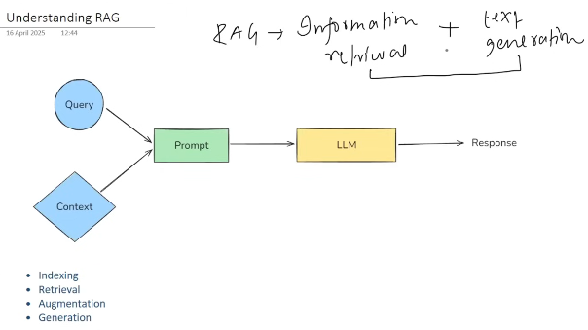

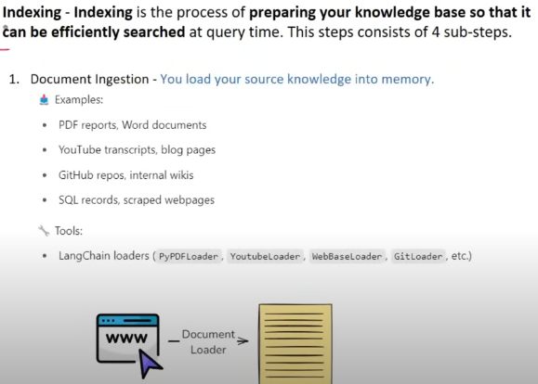

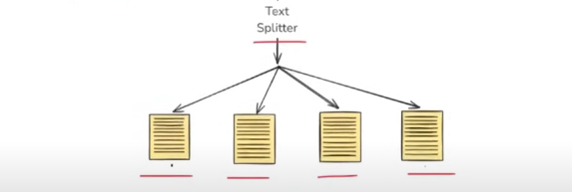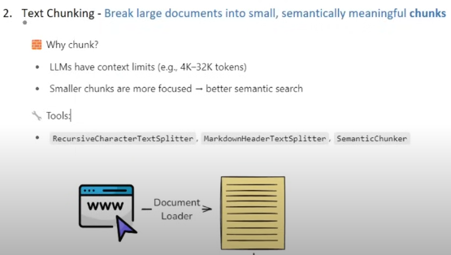

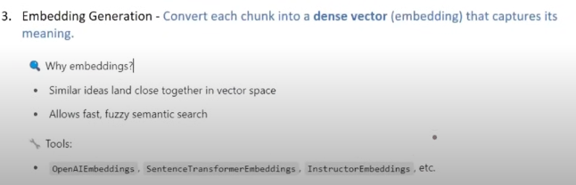

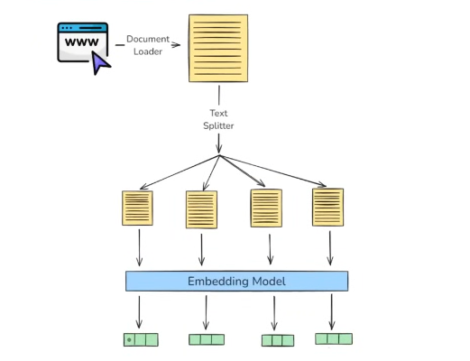

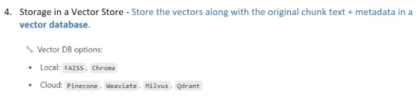

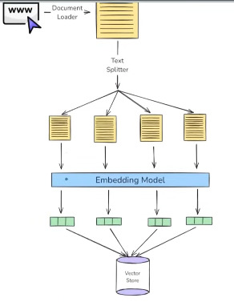

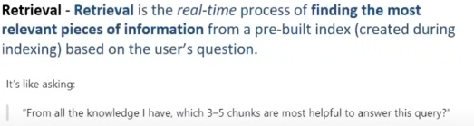

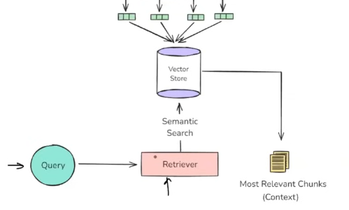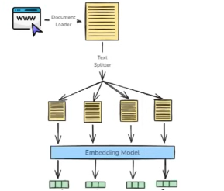

**Retrieval Process done in 4 steps:**

Step 1: Query turns into embedding with same diemensions by using same embedding model to embed vectors.

Step 2: Semantic Search (finding chunks relevant to query)

Step 3: Ranking (Ranking most relevant chunks)

Step 4: Fetch Top results.

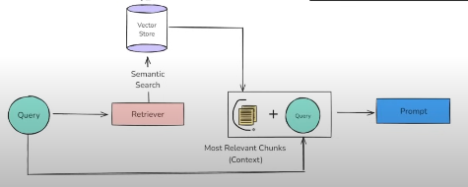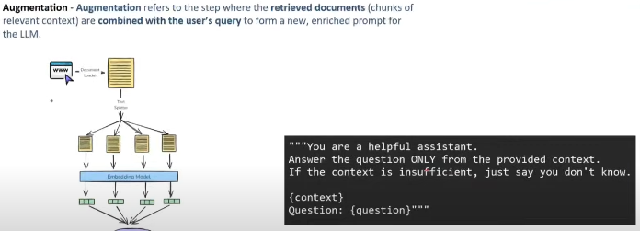

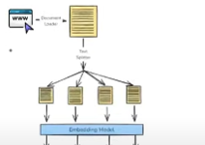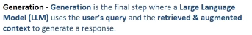

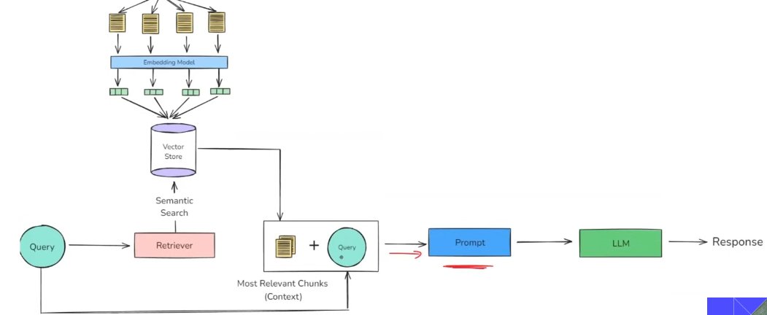

**Now all the challenges resolved,**

1. Now the model is give answers according to private data (as external knowledge base (context) is provided,
2. For updated information, we have to only update knowledge base not fine-tuning of model which save extensive computation,
3. As model have proper context, and particular instruction to give answer according to that context and if not present so say just don’t know so it does not give made-up (wrong context results).

**Topic: 2.6:** **Application using RAG**

**Application:**

**We will make a Youtube chatbot where you can provide id of any youtube video and asks questions (queries) about that video.**

**Example 1: (Without using chains)**

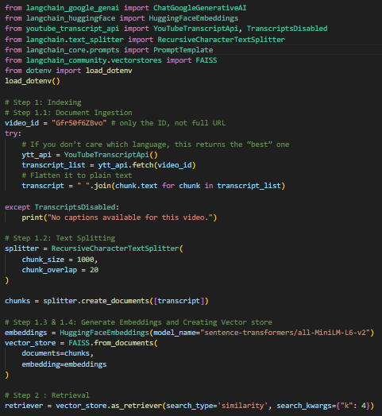

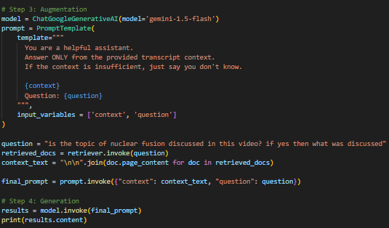



**Example 2 : (with chains)**

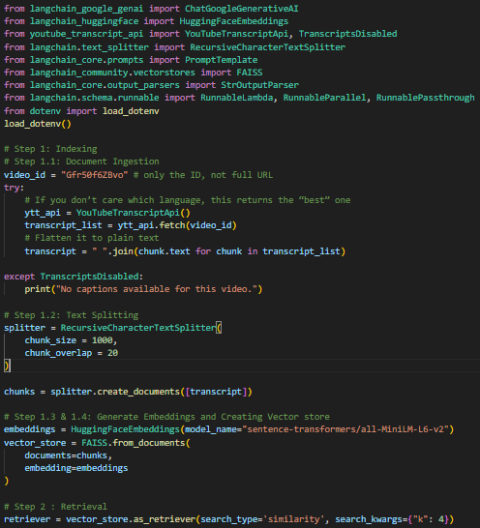

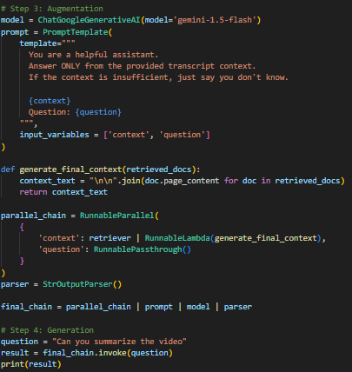

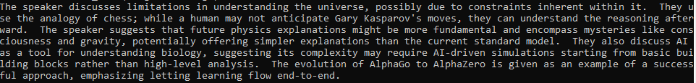

**Topic: 3.1.** **Tools and Toolkits**

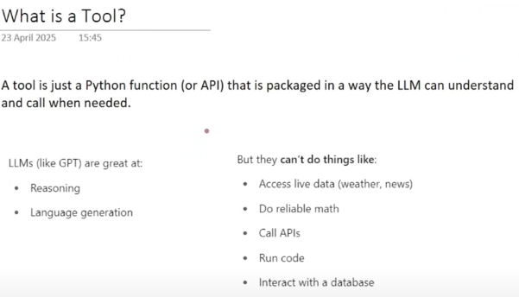

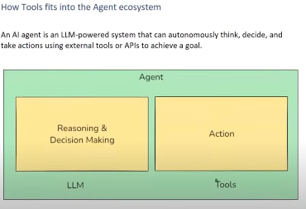

**Tools can be categorized is as follows.**

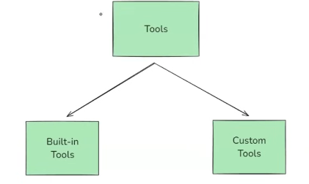

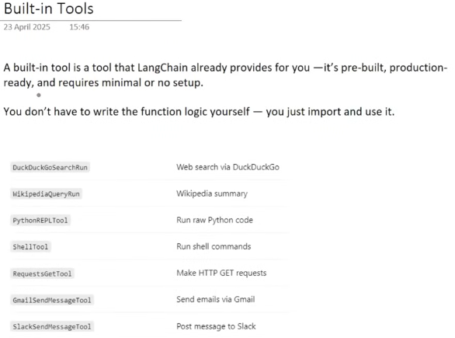

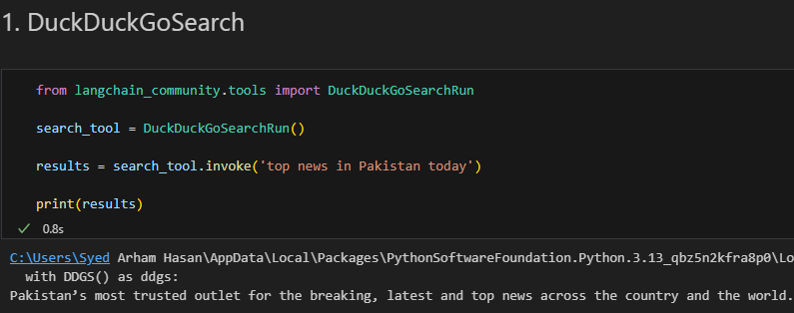

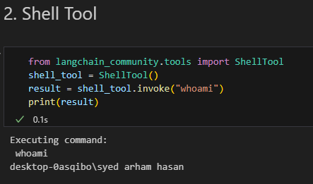

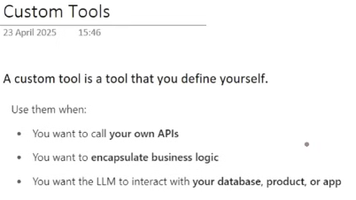

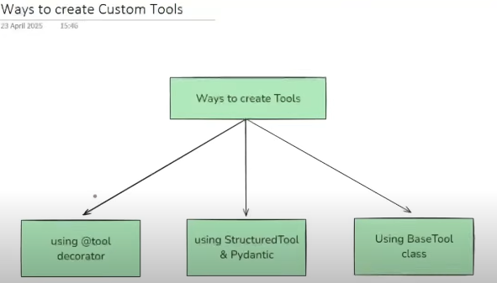

**Steps to Create a Custom Tool:**

**Way 1: using @tool decorator**

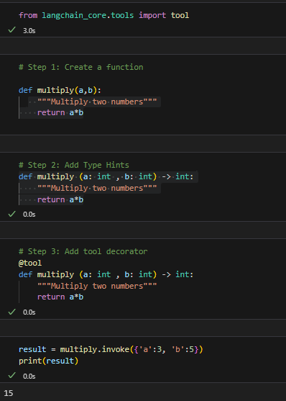

**Tool’s description**

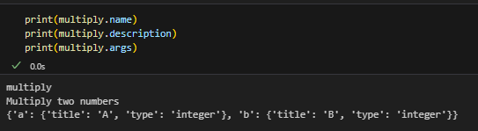

**# When you send this tool to LLM so LLM does not see tool's description as above but sees as json schema as below.**

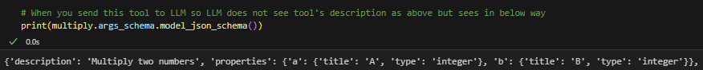

**Way 2: using Structured Tool and Pydantic**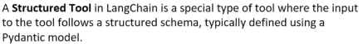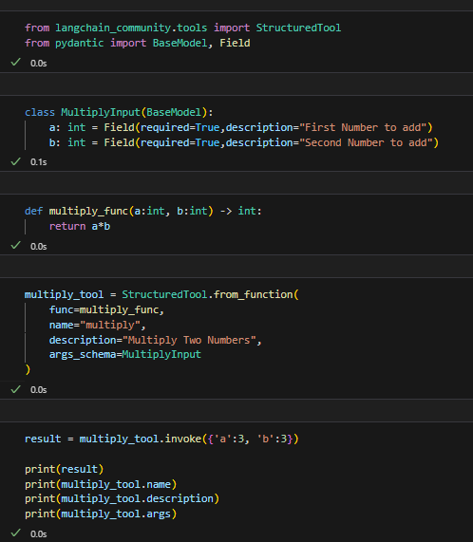



**Way 3: Using BaseTool**

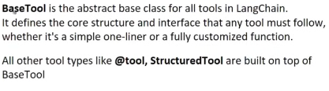

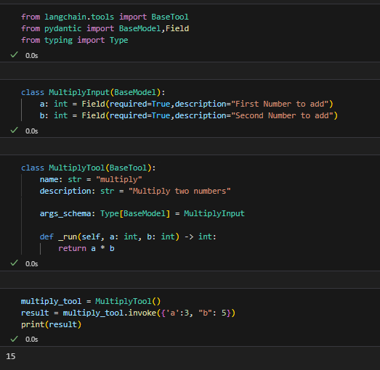

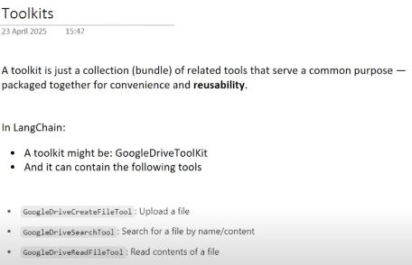

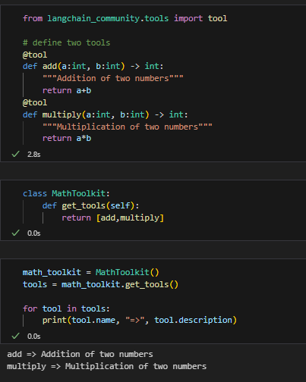

**Topic: 3.2.** **Tools Integrations**

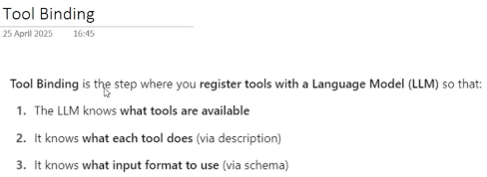

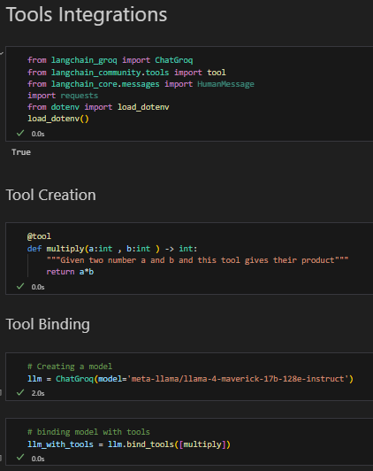

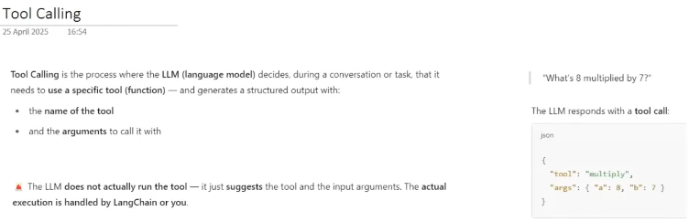**For example:**

User ask a query about any general information like what is GenAI so it answers it through its parameteric knowledge, but when a users give query to multiply 8 with 7 so LLM checks what are the available tools to perform this action, if it finds some tools that helps to perform this task so it only suggest the tool by generating a structured out with tool name and the arguments that tools required to perform action.

**Example 1 :**



AIMessage(content="I'm good, thanks. How can I assist you today?", additional_kwargs={}, response_metadata={'token_usage': {'completion_tokens': 13, 'prompt_tokens': 687, 'total_tokens': 700, 'completion_time': 0.02794297, 'prompt_time': 0.018665769, 'queue_time': 0.059732408, 'total_time': 0.046608739}, 'model_name': 'meta-llama/llama-4-maverick-17b-128e-instruct', 'system_fingerprint': 'fp_c527aa4474', 'service_tier': 'on_demand', 'finish_reason': 'stop', 'logprobs': None}, id='run--12e822e5-618a-47de-901d-cf259325b10a-0', usage_metadata={'input_tokens': 687, 'output_tokens': 13, 'total_tokens': 700})

So in Above response there is no **tool calling** in response of AI because AI understand that there is no need of calling any tool for this query.

**Example 2 :**

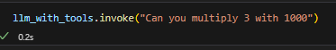

AIMessage(content='', additional_kwargs={'tool_calls': [{'id': 'x84xyhgh1', 'function': {'arguments': '{"a":3,"b":1000}', 'name': 'multiply'}, 'type': 'function'}]}, response_metadata={'token_usage': {'completion_tokens': 29, 'prompt_tokens': 688, 'total_tokens': 717, 'completion_time': 0.052784518, 'prompt_time': 0.019997092, 'queue_time': 0.012764071, 'total_time': 0.07278161}, 'model_name': 'meta-llama/llama-4-maverick-17b-128e-instruct', 'system_fingerprint': 'fp_c527aa4474', 'service_tier': 'on_demand', 'finish_reason': 'tool_calls', 'logprobs': None}, id='run--516250ca-1a1f-4986-b18c-3c7b9b4a2bfc-0', tool_calls=[{'name': 'multiply', 'args': {'a': 3, 'b': 1000}, 'id': 'x84xyhgh1', 'type': 'tool_call'}], usage_metadata={'input_tokens': 688, 'output_tokens': 29, 'total_tokens': 717})

*So for above query LLM understand about the need of multiply tool to perform this action and suggest the tool with name and its arguments.*

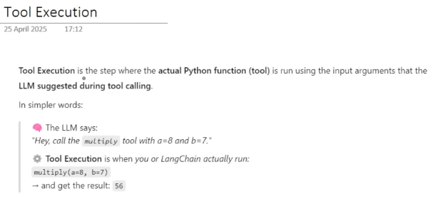

**Now I am pasting code from after tool binding for proper understanding of concept.**

So first we convert a user query into **HumanMessage** and send to model which gives **AI Message** Which we append in messages list to maintain proper context then we send **tool_call** to our multiply tool **(Tool Execution)** which gives us **ToolMessage** (result)which stores in tool_result and then append in messages list, and in final whole message list provide to last LLM calls to provide final result. As, LLM have whole context about user’s query, AI response and tool result so it generates accurate output thorugh it.

**Topic 3.3: Building an AI Agent**

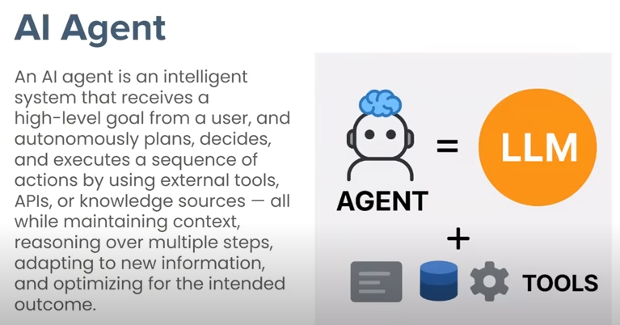

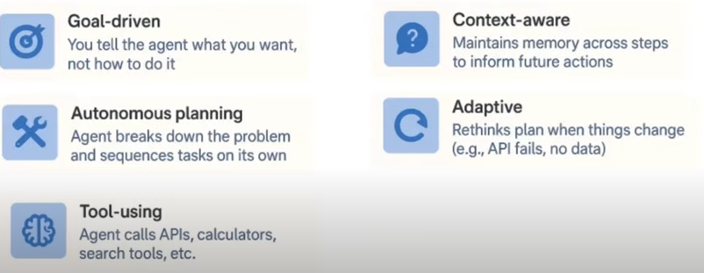

**Usecase:**

**We are creating an simple AI Agent which has access of 2 tools , one is duckduckgosearch for search on web and weather API to fetch current weather info and answer the query by using these tools.**

* **We will use a type of agent called (ReAct) agent.**

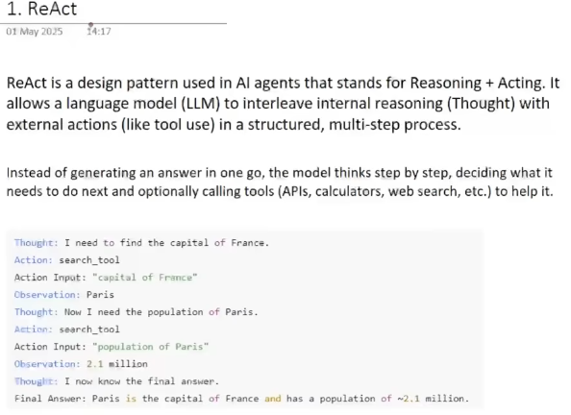

User’s query: What is the capital of France and how much population is it have?

As you see in above example in what way an agent try to give answer of user’s query by analyzing and responsing step by step, A continuos loop of **(Thought, Action, and Observation)** is run in ReAct Agent until it reaches its Final Answer. (***Agent*** *have a* ***Thought*** *realted to query, and suggest an* ***Action******(through search_tool)*** *to solve this thought and provide an input to* ***Action (Action Input)*** *this Action and Action Input then Receive by* ***Agent Executer*** *which executes the suggested Action (search_tool) with Action Input* and return Action(search tool) answer to **Agent**, the answer is called **Observation**) **(It may have access of a search tool through which it can finds these up-to-date answers.)**

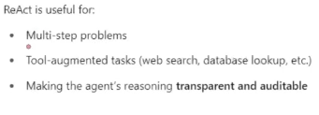

**If you see the ReAct Design Pattern (and its prompt) so you can see on Langchain Hub**

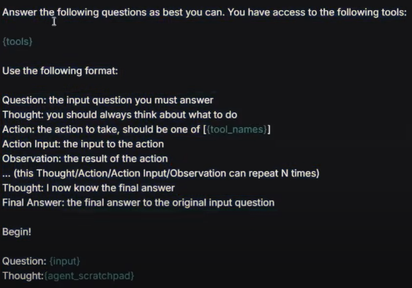

**This above is the prompt for ReAct design Pattern (which you can access from hub through hub.pull('hwchase17/react')” that helps in creating ReAct Agent. While creating agent we will provide this prompt to agent so it helps agents to reason in above pattern way.**

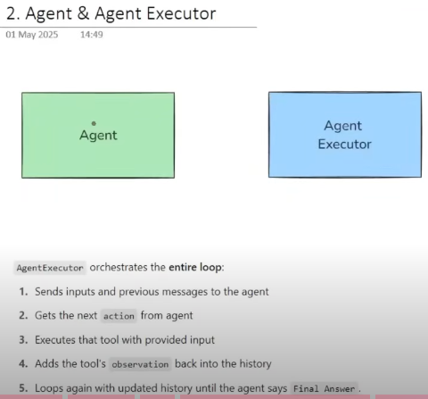

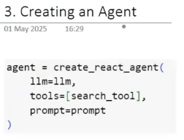

This agent object can take user’s query and Thought Trace (Means answers of whole loop of Thought, Action, Observation) and can generate two outputs , one is **Action** and the other is **Final output** if agent generate **Action** so we call **Agent Executer** to execute Action and after executing it adds **Observation** result to Though Trace and returns updated Thought Trace to **Agent**, else if generates **Final output** so loop breaks and output shown to user.

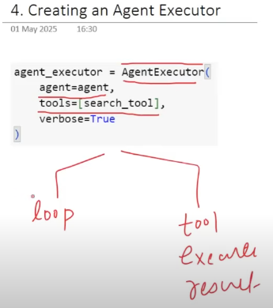

Agent executer manages entire loop, and executes tools and return results of tools.

